Maryanne Demasi, PhD

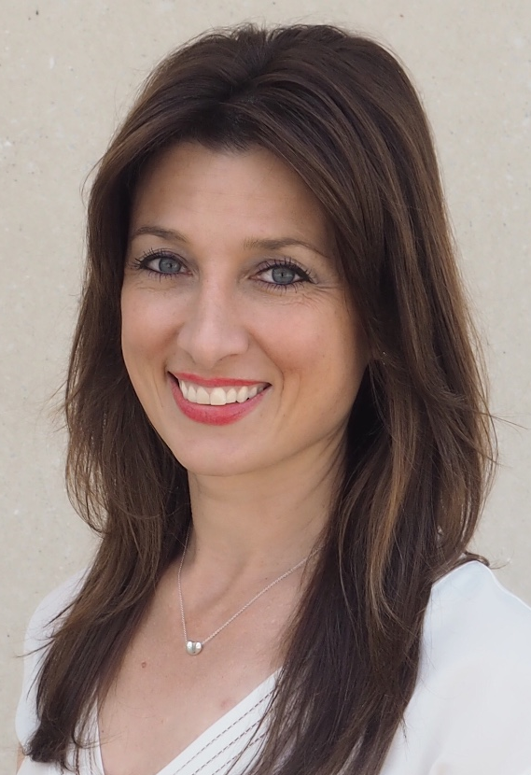

Maryanne Demasi, PhD is an award-winning investigative journalist from Australia. For over a decade, she worked as a filmmaker and TV presenter for the Australian Broadcasting Corporation (ABC TV) and has been awarded three national press club awards for Excellence in Health Journalism. Dr Demasi is renowned for her challenging and formidable investigations into the chemical, medical, food and drug industries and for raising awareness about the harms of over-diagnosis and unnecessary therapies. She has written for the Guardian and Huffington Post and has published academic papers in major medical journals such as the BMJ, the British Journal of Sports Medicine and BMJ-Evidence Based Medicine. Dr Demasi lectures around the world on issues such as scientific bias and censorship, conflicts of interest and flawed clinical trials. She obtained a PhD in Rheumatology from the University of Adelaide and has also worked as a speechwriter and political advisor the to the South Australian Minister for Science and Information Technology. Dr Demasi sits on the Executive Board of the Public Health Collaboration Australia (PHCAus), a not-for-profit charity that aims to reduce the burden of chronic diseases like obesity and type-2 diabetes. Dr Demasi can be contacted on www.maryannedemasi.com or Twitter @MaryanneDemasi

