**Horrible YouTube censorship - again related to COVID-19**

By Peter C Gøtzsche

8 November 2022

On 30 September, [I was interviewed](https://www.youtube.com/watch?v=U2m3LfdTd-E&t=1423s) by enGrama in Spain for an hour about organised crime in psychiatry and the drug industry:

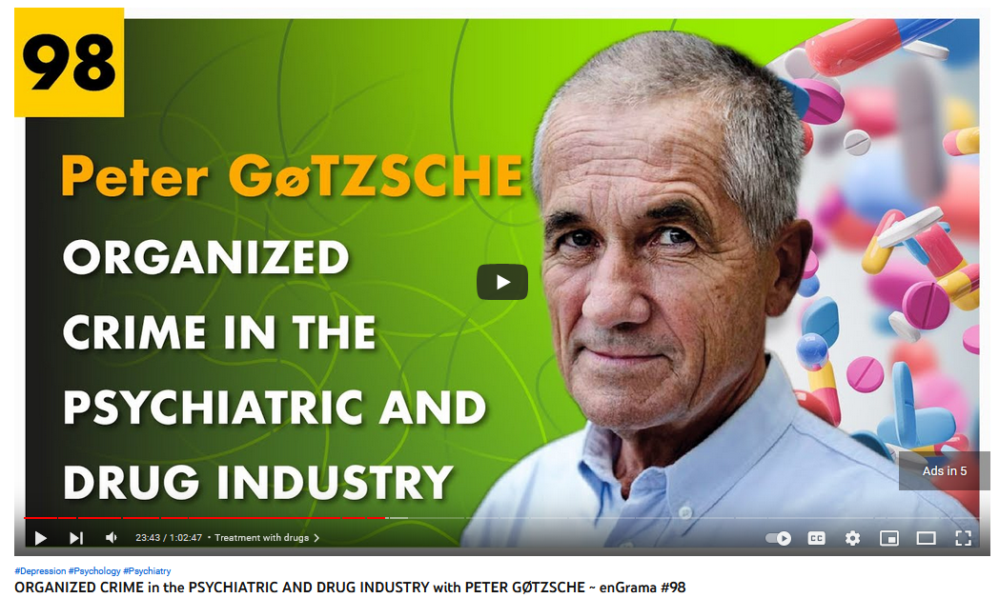

Two psychologists interviewed me, Marcos de Andrés Ortega and Luis Miguel Vega Monzón. The next day, they wrote that they had recorded the interview directly on YouTube and that YouTube had instantly eliminated the whole interview.

The interviewers had not spared a copy and they tried to convince YouTube to allow them to download their own video but to no avail.

One month later, Ortega and Monzón told me they had solved the problem. They could access their video via the YouTube Studio and they reproduced the video in this studio. They did a screen capture, introduced the labels, the text, and the subtitles. They then censored the five minutes where I talked about COVID-19 and the vaccines, because YouTube had informed them that those bits violated the channel’s guidelines.

They had to comply with YouTube’s totally inappropriate censorship in order to be allowed to upload the video again.

I have seen the whole interview and provide a summary below, including – after 55.50 minutes and one hour - what made YouTube delete the video. This was utterly ridiculous.

***

1.00 It is explained that YouTube took the video down and that the interviewers do not know why, which YouTube never explained to them. They succeeded to recover it but with poorer quality than the original.

2.50 Peter is the most cited Cochrane researcher in the world.

3.40 Why I focused on psychiatry? History is repeating itself. Withdrawal symptoms of benzodiazepines and depression pills are virtually the same.

5.00 Depression pills destroy people’s sex lives.

5.30 Psychiatrists deny the facts. It is the worst of all medical disciplines. Psychiatry does more harm than good and should be abolished.

6.10 Psychiatrists use psychiatric drugs far too much, which do not really help people but make it more difficult for them to come back to a normal life.

6.30 Psychology, can we also abolish that? No. The worst error you can make could be to look up a psychiatrist. This is far too dangerous. You should look up a psychologist or a psychiatrist who does not use psychiatric drugs but psychotherapy.

7.40 My daughter and I have shown in a systematic review that psychotherapy halves the risk of a new suicide attempt.

8.10 Depression pills double the risk of suicide, both in children and adults.

9.00 Can we trust psychiatric research? No, it is generally highly unreliable. Industry’s data analyses are biased. Harms have very often been eliminated from the papers, even deaths. Half of all deaths and suicides disappear before publication.

11.00 The myth that people become depressed etc. because they have a chemical imbalance in their brain is one of the biggest lies in psychiatry. People almost always become depressed because they live depressing lives. A psychiatrist wanted to prescribe a depression pill to a patient but the patient became angry: I do not need a pill; I need a job! Claiming there is something wrong with your brain is utterly wrong and moves the problem from your living conditions to yourself.

12.00 It is a very harmful lie. Sometimes patients are told it is like needing insulin, which means they won’t stop taking their drug. Many patients take these harmful drugs for life.

13.00 Psychosis pills are not antipsychotic because they don’t really work for psychosis. They knock you down so that you have difficulty doing anything. Their original name was major tranquillizers, which is what they do. They don’t have any specific effects in psychosis; they work in the same way in patients, healthy people and animals and make it more difficult to ever come back to a normal life. I know several psychiatrists who never use psychosis pills; they use psychotherapy, which has been shown to be effective.

14.20 A lot of time should be used, not to pose the standard question, what is wrong with you, but to explore what happened to you. You might find out that the psychosis started with anxiety many years earlier. People who become psychotic have very often been subjected to severe trauma. Sometimes you can cure people by finding out that they were raped a long time ago.

16.30 Is electroshock harmful? ECT should be forbidden. If you have a computer problem, would you then send electric current through the computer? Many patients suffer from permanent loss of memory and some die, about one per thousand. The effect is so poor that you repeat the ECTs. I know about a black American who got more than 500 shocks.

17.50 One definition of insanity is doing more of the same when it doesn’t work. This is what psychiatrists do all the time, with ECT and their drugs. If a psychosis pill doesn’t work, they increase the dose, which increases the risk that they will kill the patient or cause permanent brain damage, which are both dose related, but it doesn’t increase the chance of an effect. This has been shown in several studies. Psychiatrists say ECT can be life saving but whenever I have asked for their documentation, I got none. I once woke up a man whom I suspected had meningitis. He was unconscious but suddenly complained loudly and became fully awake when I tried to insert a needle in his spine to tap spinal fluid for examination. Did I cure him with my needle? No.

21.15 More money is given to psychiatrists than to oncologists and heart specialists. The industry buys psychiatrists and their loyalty.

22.40 The worst practice in psychiatry? The whole specialty is totally rotten. You cannot reform this specialty because those at the top see it to their advantage to maintain it as it is. Junior doctors become indoctrinated. If you have a rotten house, you cannot repair it. You need to take it down and build a new one.

24.10 Of course people have problems. We all face difficulties in life but psychiatric diagnoses are highly unreliable. Psychiatrists disagree very much about diagnoses when they see the same patients independently, e.g. about schizophrenia and ADHD. ADHD does not exist, like an elephant does, it is just a name, just one end of a normal spectrum, a social construct.

27.00 I often use the adult ADHD scale when I lecture, and between one-third and one-half of normal people always test positive. My wife scored a full house, 6 out of 6, I scored 5 like my youngest daughter, and her totally laid back boyfriend scored 4. So, we were 4 people at the dinner table who all scored positive. It can hardly be more insane than this. And then people get drugs that are considered illegal if you buy them in the street, amphetamine or amphetamine like products.

29.10 What about the pills causing addition? Everything that changes the brain can cause addiction, including alcohol and opium, which means that you cannot stop from one day to the other but need to withdraw slowly. Psychiatrists have told me it is easier to stop heroin than psychiatric drugs, which can take years. For some people, it is impossible because the brain has changed too much.

31.30 I am a member of Critical Psychiatry Network based in the UK. Most members are psychiatrists and they want to change their specialty in a more humane direction with very little use of drugs. But this is very difficult. Even patient organisations aren’t easy; they are often financed by the drug industry. We don’t have any chance of creating a humane psychiatry, as there is so much propaganda around, which influences politicians.

33.10 The suggestions you give by the end of your Critical Psychiatry Textbook are really interesting. Is there any future for psychiatry? I read the five most commonly used textbooks in Denmark used by students of medicine, psychology and psychiatry and found so many errors that I wrote my own textbook pointing out what was wrong with the other ones. It is the same all over the world.

34.30 Those in charge of psychiatry should not be psychiatrists but psychologists and social workers who do not favour psychiatric drugs, which some of them do.

36.45 Good psychologists do good work because they know the importance of talking to people and listening to them, finding out what happened to them in the past. It is vital for psychiatric patients to be heard and understood.

37.20 There are also problems with psychological research, e.g. if the examiner knows whether the patient got psychotherapy or just some kind of usual talk and care. Even so, it is obvious that psychological therapy can be effective and it doesn’t kill patients like drugs do. In my 2015 book, I have estimated this. I used randomised trials and good observational studies that compared treated with untreated people. I found that psychiatric drugs may be the third leading cause of death, after heart disease and cancer. My estimate might be exaggerated but I used the best research I could find, and even if it is only the fourth or fifth leading cause of death, this is very, very bad for drugs that don’t really help people but make it more difficult for them to live normal lives. We should not use these drugs apart from very acute situations where the patients are totally deranged, cannot sleep, and have a terrible time. But then we don’t need psychosis pills. We can use benzodiazepines, which are not so dangerous and even seem to work better. But of course, these drugs are very cheap and it is difficult to find a psychiatrist or a drug company that will recommend them.

40.00 Your Institute for Scientific Freedom, what happened with Cochrane? My work was seen as quite threatening for mainstream psychiatry. People went after me and complained to the Cochrane leadership about me. The complaints had absolutely no merit, but unfortunately, Cochrane’s CEO did not understand what science, scientific freedom and our values were about. I was one of the founders of Cochrane. The CEO started a show trial against me, the Russian way, like Stalin did. They asked a lawyer to go through what I had done for the last 15 years, but although they paid the lawyer to find some dirt on me, he exonerated me. It didn’t matter because it was a show trial. Then, they invented all sorts of rumours about me and the official excuse was bad behaviour.

42.10 What is bad behaviour? The patients loved what I was doing, and Cochrane was created in order to benefit patients. I was the most visible person in Cochrane, so by expelling me they scored a huge own goal. When I lectured around the world after my expulsion, I was told that people had lost confidence in Cochrane because they had kicked out the person who was the symbol of honesty, scientific integrity, and science at a very high level. Cochrane is in a very bad shape today. The CEO who did all this to Cochrane and me suddenly disappeared in the middle of a month at the same time when the major funder of Cochrane, the UK National Health Research Institute, had declared they would cut their funding considerably because they were dissatisfied with Cochrane for the same reasons as I was. Cochrane is going rapidly downhill.

44.30 How can we trust Cochrane and other institutions? You cannot trust Cochrane reviews of psychiatric drugs. By far most of the trials are highly flawed. There is a lack of blinding because of the drugs’ side effects. If you put something in the placebo that also gives side effects, the effect is much smaller. Further, in almost all trials, you include people who are already on a psychiatric drug and randomise them to placebo or another such drug. Thereby, you create a cold turkey in the placebo group and some of the abstinence symptoms are the same as the disease you are trying to treat. Then the psychiatrists say that the patients have become depressed or psychotic, but it is just abstinence symptoms.

46.30 People who do Cochrane reviews are not critical enough. They accept many of these trials on face value.

46.40 Sometimes, the drug effects mimic another diagnosis and the patients then receive more drugs. Can you explain how this works? Yes, I discussed this with a professor of psychiatry once. I told him that the side effects of ADHD drugs are very similar to the diagnostic criteria for bipolar, so how can you say it is a second diagnosis and not just side effects? To my big surprise he said: I can because I am a psychiatrist! Then I gave up. I mean, they are even brainwashing themselves. It is absolutely horrible. We have seen the diagnosis bipolar in children, which was almost totally unknown 30 years ago, explode, particularly in America after they invented the diagnosis ADHD and started using stimulants. This is a huge disaster because bipolar is treated with dangerous drugs like lithium, psychosis pills and antiepileptics. Antiepileptics double the risk of suicide.

49.00 What are the values for the Institute for Scientific Freedom? A psychiatrist who never uses psychiatric drugs or electroshock told me when Cochrane had kicked me out that they needed to make an institute for me where I could continue with my work. Our values are that all science and all results must be published, also the deaths in psychiatric research, and of course you need to be completely honest. These are very simple values but they are not so common in healthcare research where there are so many incentives to be dishonest. It improves your career possibilities.

50.00 Where can people find your documentation? It is all over the place. We don’t need more research about how harmful current day psychiatry is. I have written some books and a famous science journalist, Robert Whitaker in America, wrote two books, Mad in America and Anatomy of an Epidemic, which is an epidemic of overdiagnosis and overtreatment. In all countries where this had been examined, the more you use psychiatric drugs, the more people get a disability pension. They cannot work. This shows how disastrous psychiatry is. We also have good psychiatrists that have written good books, Joanna Moncrieff, David Healy, Peter Breggin, and Jock McLaren.

52.00 We have everything we need in order to conclude that psychiatry must be abolished.

52.30 Those of us who have written these books have also documented what is wrong with the science mainstream psychiatry refers to. So, it is not a question of whether to believe us or the other side. It is very simple. For example, many psychiatrists have written articles where they say that psychosis pills *lower* mortality. These are some of the most harmful and dangerous drugs ever invented. I have documented, based on randomised trials, that these drugs double mortality. Psychiatrists are willing to do very poor research with a lot of bias where they claim the opposite. It is very easy to show the bias but in the psychiatric world, it doesn’t matter. People just won’t listen.

54.00 On my website, [https://www.scientificfreedom.dk](https://www.scientificfreedom.dk/), one can download some of my work for free. I have recently provided two of my books for free in Spanish, the psychiatry book from 2015 and my book about organised crime in the drug industry from 2013. The reason that I offer them for free is that my Spanish publisher is a thief. He steals the royalties he owes me. He refuses to pay me my royalties and he has done that to other authors and has also refused to pay his translators. My contracts with him have expired, so I can do what I want. My Spanish publisher is a crook.

55.50 What is your opinion about how science is constructed today, with publications and payments of researchers? I illustrated this with the censorship during the COVID-19 pandemic …

The next 2½ minutes were removed from the video. Here is what I said:

COVID-19 has destroyed a lot. Not only killed millions of people but also scientific freedom. I have published a book called ‘The Chinese virus: killed millions and scientific freedom.’ And I am certainly convinced that this was a laboratory leak in Wuhan in China and I am also very convinced that the virus was manufactured in China. So, it was a man-made virus that escaped from a laboratory. In my book, The Chinese virus, I describe in detail how the COVID-19 pandemic has caused a type of censorship I had hoped I would never experience in my lifetime because it has brought us back to the Middle Ages where people were burned at the stake if they did not agree with the Catholic Church. Now, if you say something that is absolutely correct, for example, that the more times you get vaccinated against COVID-19, the greater the risk that you actually get infected, with a new strain of COVID-19. Canadian researchers have documented the same with influenza virus vaccines, that, if you are vaccinated, you increase your risk of getting infected with another influenza virus in future. So, this is being debated in the European Parliament [and the European Medicines Agency [has cautioned](https://www.reuters.com/business/healthcare-pharmaceuticals/eu-drug-regulator-says-more-data-needed-impact-omicron-vaccines-2022-01-11/) against repeated boosters because they could weaken people’s immune responses] but if you write about that on LinkedIn, your account gets suspended. This happened for my co-director at my institute. So, it is horrible, this kind of censorship we see now during the COVID-19 pandemic. In Germany, they go on and arrest people if they say something that does not agree with official policy, or WHO policy, or whatever. And the problem about agreeing with authorities is that authorities disagree with themselves. If you go from one country to another, they don’t have the same opinion. So, how can social media like Facebook and LinkedIn and Twitter, how can they say that you have now violated their guidelines, because you are not in accordance with the authorities. Which authorities? It’s very bad.

56.45 I agree with the United Nations’ rapporteur that forced treatment in psychiatry is a human rights violation that must be abolished.

57.30 Can organisations help patients stop taking the drugs? It can be very difficult. I have heard about a family that fled from USA to Canada to avoid forced drugging. USA is perhaps worse than any other country. I cannot understand how we can have such an inhumane system that forces people to take drugs that double their risk of dying and which cause permanent brain damage in the vast majority that gets treated for quite some years, which many of them do. Many develop tardive dyskinesia where they cannot control their movements, for example, which is a horrible condition, and a sign of permanent brain damage. I often think of the Middle Ages and how they treated people at that time.

1.00.00 Can you tell us about other projects? Yes, I am involved in a project with my co-director where we look at long-term harms and serious harms of the COVID-19 vaccines ...

The next 2½ minutes were removed from the video. Here is what I said:

This is a problem that has been almost totally ignored. But some people get seriously harmed by the COVID-19 vaccines, and some people even die, as you are aware of. I mean, they can cause myocarditis and other things, and perhaps also autoimmune encephalitis with inflammation in your brain. There are reports about that and with any vaccine, there will always be people who are seriously harmed because we are different and our tissue types are different. And you don’t know what happens when you stimulate the immune system. It can in some people go horribly wrong, which does not mean that vaccines are not very helpful. The best vaccines we have, they have saved millions of lives – vaccines against measles, polio, smallpox, diphtheria and so on. I also think the COVID-19 vaccines have saved very many lives. But they do harm some people. And, therefore, it should not be mandatory to be vaccinated with a COVID-19 vaccine.

1.10.00 Will you leave a last message for our audience? My main message is: Use drugs as little as possible. Our prescription drugs are clearly the third major cause of death after heart disease and cancer. And many of the drugs, people take, like ibuprofen for back pain or headache or whatever, they are actually too dangerous. These drugs can give you heart attacks and bleeding stomach ulcers that kill you if you are unlucky. So, in general, my best advice is: Think twice before you go to the pharmacy with a prescription from your doctor. Go on the Internet and read the package inserts to find out about all the harms your doctor might not have told you about. Then you might decide that maybe you don’t need the drug. Maybe it wasn’t that bad with your pain, for example.