Peter C. Gøtzsche, DrMedSci, MD, MSc
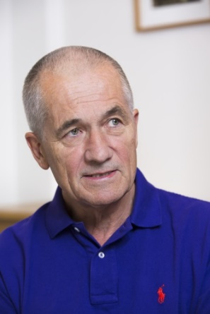
Professor Peter C. Gøtzsche graduated as a Master of Science in biology and chemistry in 1974 and as a physician 1984. He is a specialist in internal medicine; worked with clinical trials and regulatory affairs in the drug industry 1975-1983, and at hospitals in Copenhagen 1984-95. Co-founded the Cochrane Collaboration (the founder is Sir Iain Chalmers), and established the Nordic Cochrane Centre in 1993. Became professor of Clinical Research Design and Analysis in 2010 at the University of Copenhagen and has been a member of the Cochrane Governing Board twice. Co-founded Council for Evidence-based Psychiatry in the UK in 2014 and International Institute for Psychiatric Drug Withdrawal in Sweden in 2016. Founded the Institute for Scientific Freedom in 2019 and was visiting professor, University of Newcastle 2019 to 2022. Currently works as researcher, lecturer, author and independent consultant, e.g. in lawsuits.
Peter’s greatest contribution to public health was when he, in 2010, opened the archives of clinical study reports in the European Medicines Agency after a 3-year long battle that involved a complaint to the European Ombudsman. EMA was solely concerned with protecting the drug industry’s interests while ignoring those of the patients. The Ombudsman ruled there was no commercially confident information in the study reports.
Peter has published over 100 papers in "the big five" (BMJ, Lancet, JAMA, Annals of Internal Medicine and New England Journal of Medicine) and his scientific works have been cited over 190,000 times (his H-index is 91 according to Web of Science, June 2023, which means that 91 papers have been cited at least 91 times). Peter is author of several books. The most recent ones are:

- Critical psychiatry textbook (2022).
- The Chinese virus: Killed millions and scientific freedom (2022).
- Mental health survival kit and withdrawal from psychiatric drugs: a user’s guide (2022, in 7 languages).
- The decline and fall of the Cochrane empire (2022)
- Vaccines: truth, lies and controversy (2021, in 7 languages).
- Survival in an overmedicated world: Find the evidence yourself (2019, in 7 languages).
- Death of a whistleblower and Cochrane’s moral collapse (2019).
- Deadly psychiatry and organised denial (2015, in 9 languages).
- Deadly medicines and organised crime: How big pharma has corrupted health care (2013, in 18 languages). Winner, British Medical Association’s Annual Book Award, Basis of Medicine in 2014.
- Mammography screening: truth, lies and controversy (2012). Winner of the Prescrire Prize in 2012.
- Rational diagnosis and treatment: evidence-based clinical decision-making (2007).

Peter has given numerous interviews, one of which - about organised crime in the drug industry - has been seen by half a million on YouTube. Peter was in The Daily Show in New York on 16 Sept 2014 where he played the role of Deep Throat revealing secrets about big pharma. A documentary film about Peter’s reform work, Diagnosing Psychiatry, appeared in 2017, and another one, with the working title, “The honest professor and the fall of the Cochrane empire,” about his life and the moral collapse of the Cochrane Collaboration, is in production. Donations to the film can be given here.
Peter has an interest in statistics and research methodology. He has co-authored guidelines for good reporting: CONSORT for randomised trials, STROBE for observational studies, PRISMA for systematic reviews and meta-analyses, and SPIRIT for trial protocols. Peter was an editor in the Cochrane Methodology Review Group 1997-2014.
Peter is Protector for the Hearing Voices Network in Denmark.

Websites: scientificfreedom.dk and deadlymedicines.dk.
Twitter: @PGtzsche1
Email: pcg@scientificfreedom.dk

