False propaganda about face masks and Cochrane editorial misconduct

By Peter C Gøtzsche
Institute for Scientific Freedom

11 Sept 2023

During the COVID-19 pandemic, governments all over the world, apart from Sweden, mandated the use of face masks. This was a huge mistake.

Sweden not only avoided using masks but also kept its society open, despite strong international criticism. Yet, Sweden did exceptionally well. Numerous studies have shown that Sweden’s excess death rate (total mortality during the pandemic compared to the years before the pandemic) is among the lowest in Europe, and in several analyses, Sweden was at the bottom. This is remarkable considering that Sweden has admitted that it did too little to protect people living in nursing homes.

Why did governments all over the world and their so-called experts lie profusely about the effect of face masks when they don’t seem to work? Perhaps because it is a visible sign of action to dress whole populations as bank robbers. Washing hands is effective, but not visible, and therefore not something governments can praise themselves for having achieved.

Cochrane editorial misconduct related to its mask review
Cochrane editorial misconduct played a major role for the widespread use of face masks. In early 2020, Tom Jefferson and colleagues updated their 2006 Cochrane review, “Physical interventions to interrupt or reduce the spread of respiratory viruses” for the fourth time. This was timely because it was at the start of the pandemic. However, Cochrane held it back for 7 months while many countries mandated the use of face masks.
There was no good reason to postpone publication other than political expediency. This is censorship of the worst kind and also appallingly poor editorship. The Cochrane leaders knew perfectly well how important the review was for allowing the politicians to make evidence-based decisions. I fact, the mask review is the most downloaded review in the Cochrane Library with the highest altimetric score in Cochrane’s history.
Jefferson told investigative journalist Maryanne Demasi that, during those 7 months, other Cochrane researchers produced unacceptable pieces of work, using unacceptable studies, that gave the “right answer”.

Jefferson believes the purpose of the editorial Cochrane published to accompany the review was to undermine his team’s work. Its main message was that “you can't sit on your hands, you’ve got to do something, you can't wait for good evidence …. it's a complete subversion of the ‘precautionary principle’ which states that you should do nothing unless you have reasonable evidence that benefits outweigh the harms,” he said.

When Jefferson updated his review again in 2023, Cochrane committed editorial misconduct again. Someone who didn’t know much about masks, New York Times columnist and social influencer Zeynep Tufekci, a Princeton sociologist, wrote an article in the Times titled, “Here’s why the science is clear that masks work,” claiming that Cochrane’s mask review had misled the public. But her article contained numerous errors.
Cochrane’s editor in chief, Karla Soares-Weiser capitulated to the pressure and apologised for the wording in the summary of the review on Cochrane’s website, published on 10 March 2023. She wrote that, “the results were inconclusive,” and that “Many commentators have claimed that a recently-updated Cochrane Review shows that 'masks don't work', which is an inaccurate and misleading interpretation.” This is not a misleading interpretation and there was nothing to apologise for.
Soares-Weiser wrote that “the review is not able to address the question of whether mask-wearing itself reduces people's risk of contracting or spreading respiratory viruses.” This is wrong, as the review addressed precisely this question and selected the most reliable studies, the randomised trials. So, as Jefferson said, “Cochrane has thrown its own researchers under the bus again.”
He noted that Soares-Weiser had made a colossal mistake, which sends the message that Cochrane can be pressured by reporters to change their reviews.
Jefferson also said: “We do not know what spooked the Editor-in-Chief, but given the speed and highly unprofessional nature of the reaction, could it be one of their big funders?”
Or was Soares-Weiser influenced by a so-called fact-check “with absurd results” from 17 February? The fact-checker announced in the headline that, “Multiple studies show that face masks reduce the spread of COVID-19; a Cochrane review doesn’t demonstrate otherwise.” This was false, and an analysis showed that out of the eight claims the fact-checker made in her summary, four were plainly false, one was logically invalid, one was misleading and two were not supported by any evidence. The fact-checker was from “Health Feedback,” which got the evidence about face masks totally wrong also in relation to the Danish randomised trial of prevention of COVID-19 infection. I have described this deplorable affair in my freely available book, “The Chinese virus: killed millions and scientific freedom.”
In the article, “The Cochrane mask fiasco: A Cochrane report tells the truth, but many are not ready to hear it,” Vinay Prasad, a hematologist-oncologist and Professor in the Department of Epidemiology and Biostatistics at the University of California San Francisco, offers this conclusion:

“Cochrane’s EIC should be fired. If a NY Times writer calls you about a Cochrane review, and what the lead author may have said in the media, you stay silent. You don’t throw them under the bus, especially when the author was factually correct. It is bad leadership.”

Cochrane’s misjudgement led to further troubles. Former CDC director Rochelle Walensky misled the US Congress after claiming the Cochrane review had been “retracted,” which was patently false. She also told Congress that the Cochrane review was suspect because it relied on randomised trials rather than the observational evidence the CDC favours. This is absurd.
Adding insult to injury, Cochrane’s statement was interpreted widely as an apology coming from the authors, and in some cases, tweeters believed the review was retracted.
Jefferson told Demasi that his team was given “little workable notice” before Cochrane published its statement and he had no clue what the statement would entail, prior to its publication. He also noted that it was unacceptable that Soares-Weiser had gone outside the normal channels and made decisions without any consultation with the authors of the review, and he said:
“We’ve decided that we are going to write to Cochrane leadership and complain about the way this has been handled. We will answer legitimate comments on the Cochrane webpage, through our comments editor, which is the tried and tested way of handling criticisms.”
Cochrane is a member of the Committee of Publication Ethics (COPE), and it seems to me that Cochrane is in breach of the COPE guidelines for handling post-publication critiques, which specify that,
“journals must allow for post-publication discussion on their site, through letters to the editor or on an external moderated site. Post-publication discussion typically starts with a reader’s critique of an article that a journal has previously published. When formally submitted for journal publication, such critiques are commonly known as ‘letters to the editor’, ‘commentaries’, ‘comments’ or other types of ‘correspondence’.”
Cochrane has exactly such a mechanism, which allows criticisms to be published alongside the review, with the authors’ reply, but Soares-Weiser did not use the appropriate mechanism.
There is nothing wrong with the Cochrane review, which is of high quality. The randomised trials did not show any effect of face masks, neither for prevention of influenza-like illness, nor for prevention of COVID-19 infection, or when considering all respiratory infections together.

In September 2021, a large trial in Bangladesh appeared to have shown a small effect of face masks. However, the measured effect, 7.6% of people with reported COVID-like illnesses in the intervention villages compared with 8.6% in the control villages could be due to physical distancing, which was practiced by 29.2% and 24.1%, respectively.

Soares-Weiser has since taken to communicating with the authors through a consulting firm, Envoy, to clean up the mess she caused and to handle scientists’ concerns over her poor leadership. Questions about how much she is paying Envoy remain unanswered.
Cochrane Spokesperson Harry Dayantis said he didn’t know anything about Envoy. This is not true. When Soares-Weiser was forced to hire Envoy, she sent an internal email to Cochrane scientists announcing that she had retained the firm, and Dayantis is on the email.
When investigative journalist Paul Thacker asked for access to documents that involved himself, according to Article 15 of the European Union's General Data Protection Regulation, he received heavy redacted documents that could not elucidate how Cochrane had handled his request for comment and answers in relation to the scandal.
In August 2023, Thacker wrote that both Cochrane and Envoy had ignored his questions about the contract. He also explained that co-chair of the Cochrane Governing Board, Catherine Marshall, had helped Soares-Weiser draft the statement undermining the Cochrane review on masks. In her Cochrane conflict of interest declaration, Marshall failed to disclose her COVID consulting gigs with the New Zealand government that recently became public following a freedom of information request. New Zealand ignored Cochrane’s findings and implemented a stringent mask policy that has just been revoked.
Jefferson said that he also requested his personal data from Cochrane under Article 15, receiving "nearly 300 pages of nothing" with "all the important email exchanges" fully redacted. The first of Cochrane’s ten key principles is:

“Collaboration by fostering global co-operation, teamwork, and open and transparent communication and decision-making.”

This is a thing of the past when Cochrane was still an idealistic organisation. It now behaves like a drug company. Read my book, “Decline and fall of the Cochrane empire.” It is freely available.

The role of US presidential advisor Anthony Fauci

Mandating face masks was a question of politics, not science, which was wilfully ignored. When, in early September 2023, former chief medical advisor to the US President, Anthony Fauci, was questioned by a reporter from CNN about face masks being able to curb the spread of COVID-19, Fauci responded: “There’s no doubt that masks work.”

How could Fauci know this? When Demasi interviewed Jefferson, he confirmed that “There is just no evidence that they make any difference. Full stop.”
Fauci replied, “Yeah but there are other studies,” stressing that masks work on an individual basis, to which Jefferson replied: “So, Fauci is saying that masks work for individuals but not at a population level? That simply doesn’t make sense.”
“It might be that Fauci is relying on trash studies,” said Jefferson. “Many of them are observational, some are cross-sectional, and some use modelling. That is not strong evidence.”
Another problem with Fauci’s credibility is that his story has changed. Initially, in March 2020, Fauci said that masks were ineffective and unnecessary and that people should not be walking around with masks. But only a few weeks later, he did a U-turn and began recommending widespread use of face masks. Fauci defended his U-turn saying, “When the facts change, I change my mind.”
Jefferson retorted, “What facts changed? There were no randomised studies, no new evidence to justify his flip-flop. That’s simply not true.” Jefferson noted that Fauci was in a position to run a randomised trial, comparing regions with and without mask use, “But he didn’t and that’s unforgivable.”
Recent events in the UK were also deplorable
In August 2023, the Royal Society of Medicine (RSM) published four systematic reviews that informed about the effectiveness of non-pharmaceutical interventions in the COVID-19 pandemic.

All four reviews noted that the data they had included – which were from observational studies - were biased and did not allow the readers to have any confidence in the findings. But this was ignored by the chair of the working group who pronounced victory for the government’s drastic measures when there was none.

The Royal Society of Medicine did a huge disservice to public health. Refusal to acknowledge the huge limitations in the studies they claimed had shown an effect undermines public trust in research.

The media behaved like the rulers’ useful idiots, or should we say, more politely, as uncritical microphone holders. The headlines said it all. Politico: “Top review says COVID lockdowns and masks worked, period.” The Guardian: “Lockdowns and face masks ‘unequivocally’ cut the spread of Covid, report finds.” The I newspaper: “Masks and social distancing did reduce Covid infections, new report shows, proving lockdown skeptics wrong.”

The lockdown skeptics and the face mask skeptics were not wrong. They were right.

Final words
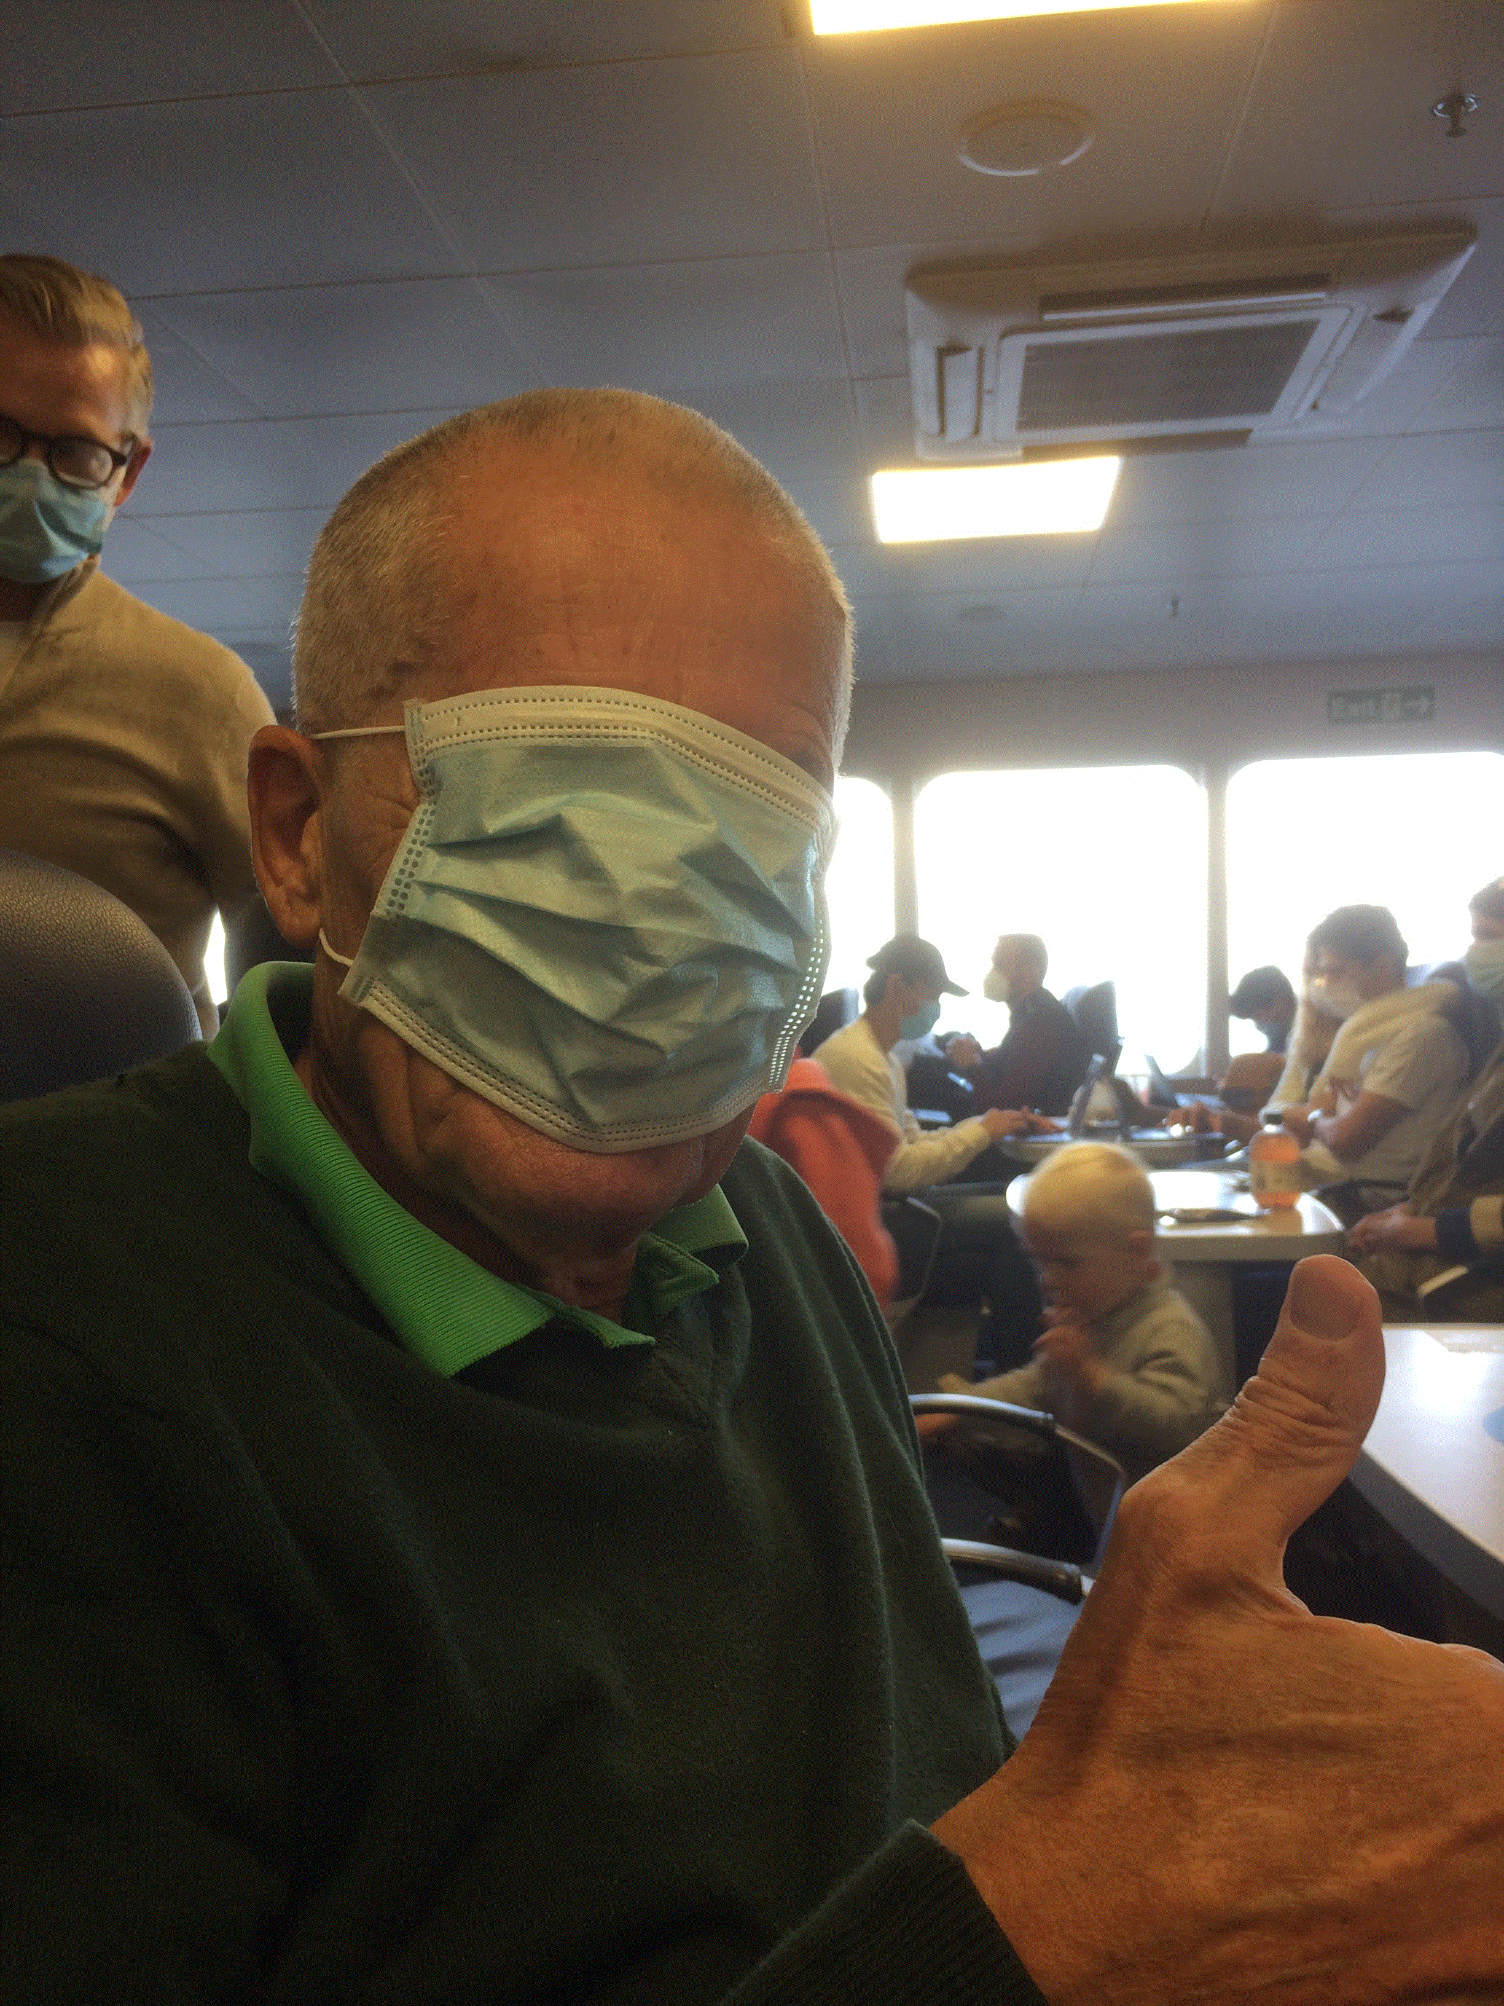
In 2020, a woman greeted me on the ferry. I did not know who she was, as she was masked. It turned out to be one of my PhD students. It took me more than an hour to drink my coffee because this allowed me not to wear a mask. I let the mask cover my eyes, too, when I had no more coffee.

Perhaps Fauci, the Royal Society of Medicine, and the useful idiots among journalists are also wearing a face mask over their eyes so that they are certain they cannot see the facts about face masks.
So, let’s face the facts without being masked. High-quality evidence (randomised trials) show that face masks don’t work. Low-quality evidence “found strong evidence that masks work,” as they say in the UK. This is nonsense. Observational studies are full of bias and cannot be strong evidence, particularly not when trials have found the opposite.
As Tom Jefferson said recently in an interview, we have a very good observational study of the whole UK population. Virtually everyone has become infected with COVID-19 despite the government’s mandate of using face masks and the lockdown. What does this tell us?
Furthermore, have you ever heard of anyone who used face masks correctly? I haven’t. People tend to use the same mask for weeks until it disintegrates.
How low can you sink? Apparently to the ethical bottom, if you are a political leader, or are one of the pandemic’s “overnight experts” that provide advice to the government –- and want to continue being seen as indispensable.
What I miss the most is for the WHO and governments to demand a ban on the highly dangerous gain of function experiments that were carried out in Wuhan with US financial support. It is highly likely that the COVID-19 pandemic was caused by a lab leak of a manufactured virus that was made dangerous on purpose. Why don’t we learn from history and ban this playing with fire research, which has led nowhere apart from killing over seven million people. Read my book, “The Chinese virus: killed millions and scientific freedom,” and be shocked. It is freely available. And see my podcast channel where we shall discuss face masks and lockdowns in several of the episodes.

