25 Sept 2023

Open letter to:

Editor Anette Flanagin, [jamapsych@jamanetwork.org](mailto:jamapsych@jamanetwork.org)

JAMA Psychiatry (previously Archives of General Psychiatry)

**Second call for retraction of a fraudulent trial report of fluoxetine in children and adolescents**

Dear Anette,

We sent an [open letter](https://www.scientificfreedom.dk/2023/08/03/call-for-retraction-of-three-fraudulent-trial-reports-of-antidepressants-in-children-and-adolescents/) to JAMA Psychiatry on 3 August where we asked the journal to retract a fraudulent trial report of fluoxetine with Graham Emslie as first author.

You responded by email on 21 Sept to me:

*“We have reviewed your letter. As you know, we previously responded to similar requests from Maryanne Demasi, who works with you. We shared your letter with the author of the study published in Archives of General Psychiatry and he does not identify any new concerns. Similarly, we do not find new evidence in support of your request to retract this article.*

*You may share our response with your cosigners, to whom we offer our sincere condolences.”*

You and I know each other well. We have, for example, met at several peer review congresses arranged by JAMA. I am very surprised and disappointed by your reply, given what I know about you, and we kindly ask you to reconsider your decision.

In the letter we wrote to your journal, we outlined a large number of important discrepancies between what Graham Emslie et al. published in your journal in 1997 and the data Eli Lilly presented in the clinical study report of 1008 pages they submitted to the FDA to get fluoxetine approved for treatment of children and adolescents.

We wrote, for example:

*“In trial X065, two of 48 patients attempted suicide on fluoxetine, but these suicide attempts were left out from the published report. Four additional patients discontinued fluoxetine because of adverse events called “minimal” in the published report, even though three of them developed manic symptoms and the fourth had a severe rash.”*

You say that JAMA Psychiatry “do not find new evidence in support of your request to retract this article.” Your argument is invalid because we provided you with such new evidence in our letter of 3 August. We described the fraud in a published, peer reviewed article, which we enclosed in our open letter of 3 August. This article is [freely available](https://www.scientificfreedom.dk/2022/11/08/fluoxetine-in-children-and-adolescents-with-depression-is-unsafe-and-ineffective/) on the website of the Institute for Scientific Freedom. In case you want to check that what we write in this article is correct, you can access Eli Lillys clinical study report [here](https://www.scientificfreedom.dk/links/) (it is called Protocol B1Y-MC-X065).

You say: “We shared your letter with the author of the study published in *Archives of General Psychiatry* and he does not identify any new concerns.” So, you ask the person who is responsible for the scientific misconduct and when he says there is nothing wrong, you accept this, even though we have demonstrated the misconduct objectively. This is not how a medical journal should address scientific misconduct. The two suicide attempts on fluoxetine are mentioned already on page 5 in Eli Lilly’s synopsis of the study:

*“Two serious adverse events of suicide attempt occurred in patients receiving fluoxetine treatment during the study. Both events were considered to have unknown causality as determined by the principal investigator and occurred early in the study (after 12 and 15 days of therapy, respectively). One patient discontinued from the study as a result. Four additional fluoxetine-treated patients were discontinued from the study due to adverse events. Two patients were discontinued for hypomania, 1 for increased impulsivity, and 1 for rash. Three of the events (increased impulsivity, rash, and 1 event of hypomania) were considered possibly related to fluoxetine treatment. No placebo-treated patients discontinued due to adverse events.”*

The evidence of fraud is clear and indisputable. [Drug companies are not keen to inform anyone about suicide attempts in their clinical trials](https://www.amazon.com/Deadly-Psychiatry-Organised-Denial-Gotzsche-ebook/dp/B014SO7GHS) so when they do this, they should be trusted rather than what a psychiatrist and his colleagues published in a journal about the same trial.

Antidepressants carry a black warning in their package inserts because they double the risk of suicide in children and adolescents. And still, you do not think the study should be retracted. So, suicide attempts in children caused by an antidepressant drug don’t matter?

We assume all JAMA journals are members of the Committee on Publication Ethics (COPE). According to COPE, editors should consider retracting a publication if they have clear evidence that the findings are unreliable. This is the case here. Eli Lilly had access to Emslie’s data and provided a much more comprehensive and trustworthy report than his publication.

We asked your journal to retract the Emslie article. You refused to do this. You have not even published an erratum and have not invited us to publish our findings, asking Emslie to reply in the same issue. You have done absolutely nothing.

You write to us: “As you know, we previously responded to similar requests from Maryanne Demasi, who works with you.”

In her email from 19 July 2021, Demasi requested that the authors correct the reporting of the adverse events for Emslie’s study through an erratum. She noted that the trial publication “was missing essential information and there were unexplained numerical inconsistencies. Specifically, there are discrepancies between the adverse events reported in the CSRs and the publication. This was one of two pivotal trials, upon which fluoxetine received its license in the United States, in 2002. Correcting the information related to adverse events could impact the conclusions of the publication, as well as the ability for clinicians to make fully informed decisions about the harms and benefits of fluoxetine in the treatment of depression in children and adolescents.” Demasi attached a detailed letter.

You replied to Demasi on 22 October 2021: “We have carefully evaluated your concerns and the originally published article and have concluded no action is necessary.”

This is the type of reply drug companies excel at when they have committed scientific fraud. It is not a reply one would expect from a reputable medical journal when serious errors have been identified in a published trial report that are important for public health.

If you want your journal to be seen as being reputable and respected, you must do better than this. *BMJ*’s former editor, Richard Smith, once wrote a paper with the informative title, “Medical journals are an extension of the marketing arm of pharmaceutical companies.” Is that how you want people to perceive what JAMA Psychiatry is?

We kindly ask you, in the public interest:

1 To reconsider your decision not to retract Emslie’s paper.

2 If you still do not want to retract the paper, then to publish an erratum where you explain that what was published was seriously misleading and that many of the numbers presented in the article contrasted with the numbers in Eli Lilly’s clinical study report about the same trial.

3 If you still do not want to retract the paper, then to give us the opportunity to publish an account of the many errors in Emslie’s article, asking him to respond in the same issue. Such an opportunity should not be limited to a short letter to the editor, with a word count. It needs a full article, as there are so many errors in Emslie’s paper.

4 To forward to us Emslie’s reply to you where he indicates that there is nothing to be concerned about in his article.

We feel it is your ethical duty towards the patients and their relatives to do this.

We are looking forward to your reply.

Yours sincerely

Peter C. Gøtzsche, Professor Emeritus, Institute for Scientific Freedom, Copenhagen

Maryanne Demasi, PhD, Journalist, Institute for Scientific Freedom, Copenhagen

Kim Witczak, Minnesota, Consumer Representative at the FDA Psychopharmacological Advisory Group meetings, lost her 37-year old husband to drug induced suicide. He was prescribed sertraline because of insomnia and hanged himself.

Denis Terrida, Denmark, lost his 20-year old son to drug induced suicide. He was prescribed sertraline because he did not feel well psychologically and hanged himself.

Maria Bradshaw, New Zealand, lost her 17-year old son to drug induced suicide. He was prescribed fluoxetine because he was stressed due to a breakup with a girlfriend and hanged himself.

Stephanie McGill Lynch, Ireland, lost her 14-year old son to drug induced suicide. He was prescribed fluoxetine for anxiety and shot himself.

Leonie Fennell, Ireland, lost her 22-year old son to drug induced suicide. He was prescribed citalopram after he broke up with his girlfriend and stabbed himself and his ex-girlfriend’s new boyfriend to death.

Wendy Dolin, Illinois, lost her 57-year old husband to drug induced suicide. He was prescribed paroxetine because of anxiety at work and threw himself in front of a train.

Mathy Downing, Maryland, lost her 12-year old daughter to drug induced suicide. She was prescribed paroxetine because of school anxiety and hanged herself.

Maryellen Winter, New York, lost her 22-year old daughter to drug induced suicide. She was prescribed paroxetine because of insomnia and hanged herself. Her mother gave testimony at the FDA hearing on 13 Dec 2006: <https://www.youtube.com/watch?v=_4JXyEJaGX4>).

Cheryl Miller, Kansas, lost her 13-year old son to suicide. He was prescribed sertraline because he was unhappy and hanged himself.

Kristina Kaiser, Florida, lost her 19-year old daughter to drug induced suicide. She was prescribed sertraline for “OCD like tendencies” and died from a self-sustained injury two days after a dose increase that caused akathisia.

Signatures:

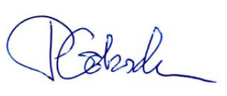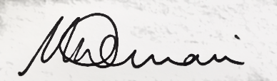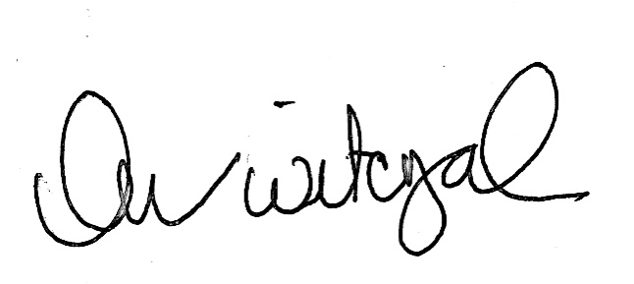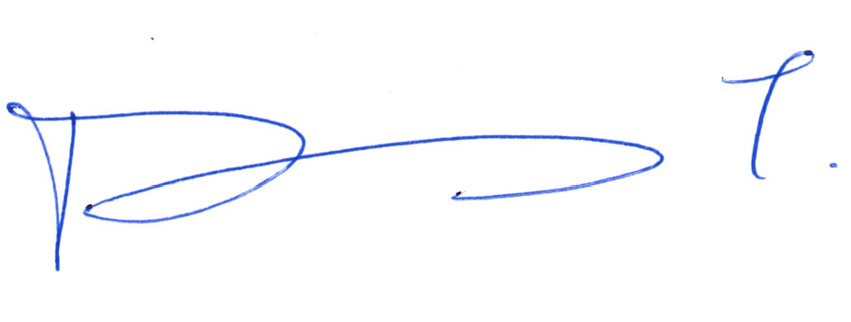

Peter C Gøtzsche Maryanne Demasi Kim Witczak Denis Terrida

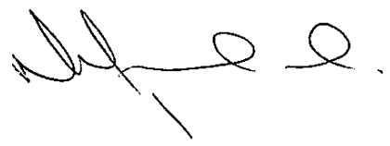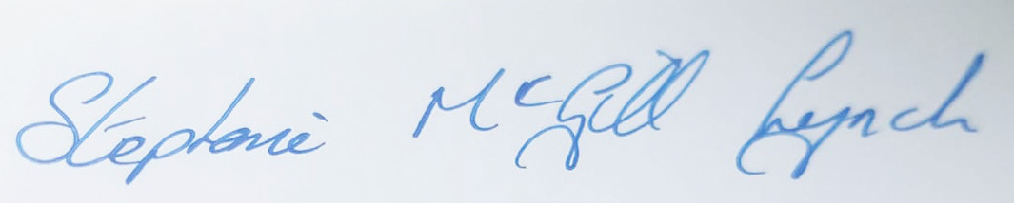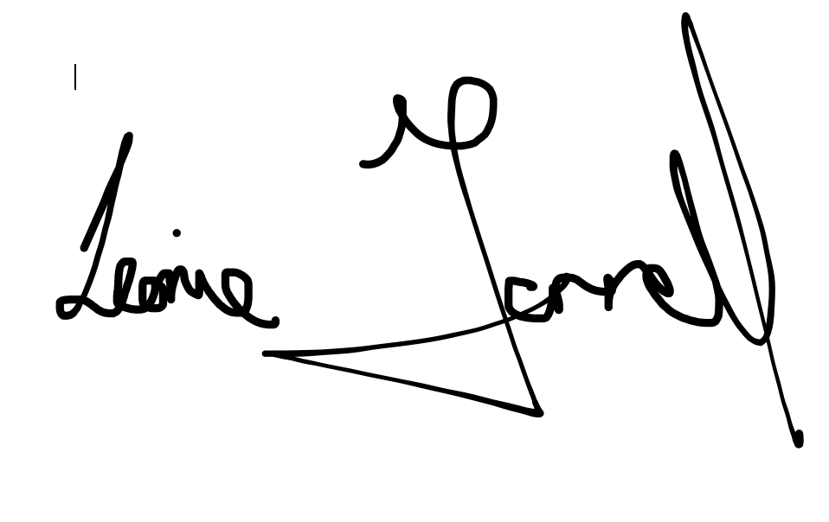

Maria Bradshaw Stephanie McGill Lynch Leonie Fennell

Wendy Dolin Mathy Downing

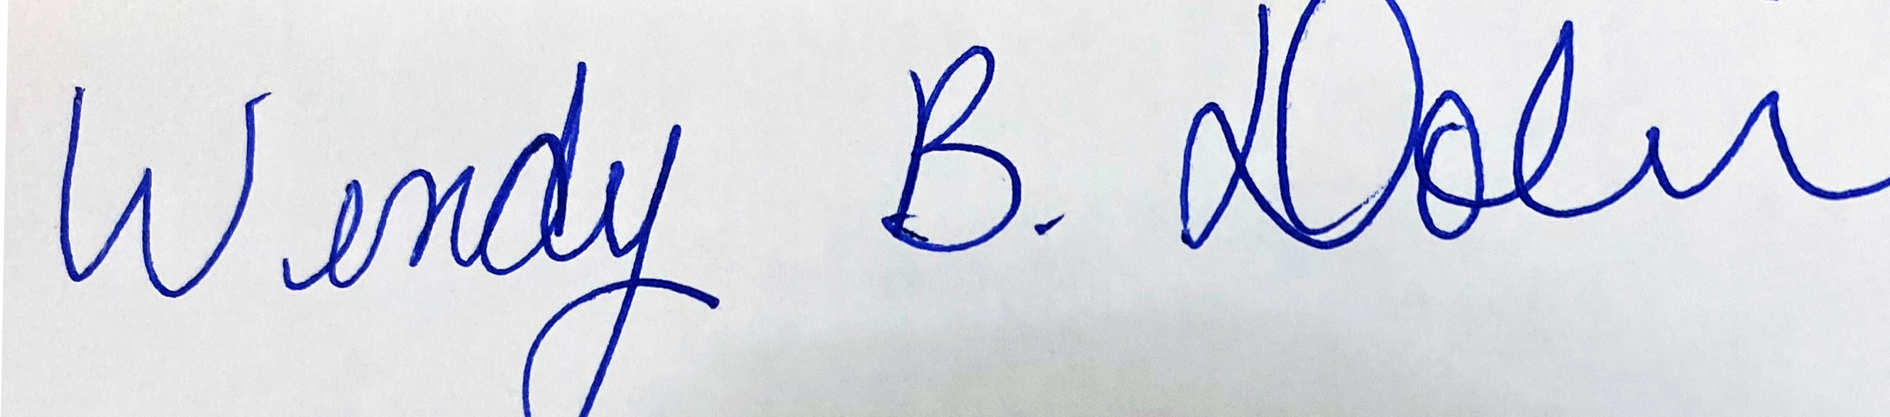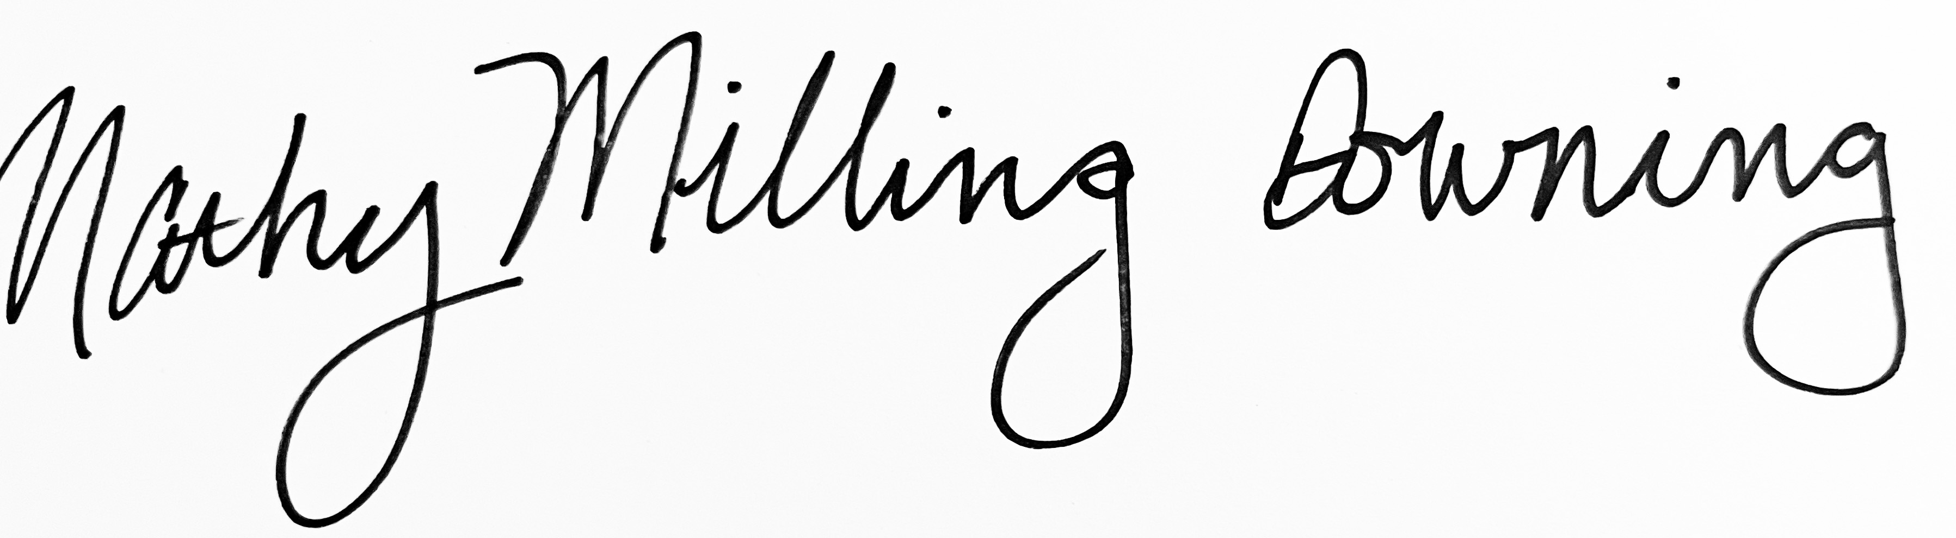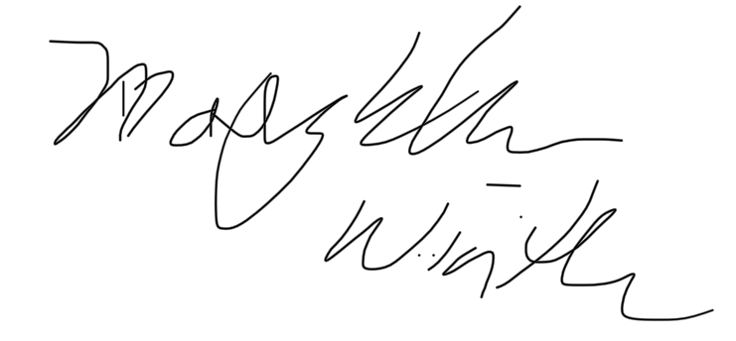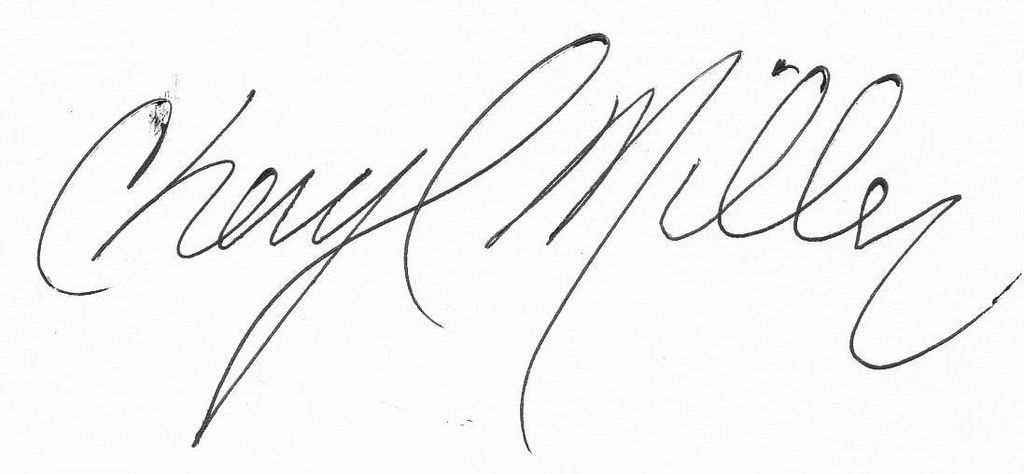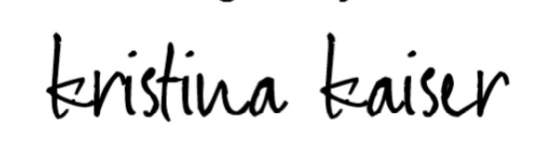

Maryellen Winter Cheryl Miller Kristina Kaiser