My career in exposing fraud, bias and injustice in healthcare

By Peter C Gøtzsche
Institute for Scientific Freedom

4 December 2023

Sir Iain Chalmers, the founder of the Cochrane Collaboration, and Jeremy Howick invited me to give a lecture in 2019 at an MSc course in Oxford about the history and philosophy of evidence-based healthcare. They asked me to share my personal experiences and research on conflicts of interest under the heading, “Power versus rationality.” In other words, it was about speaking truth to power. As this subject might have general interest, I have summarised my lecture here.

About 40 years ago, I worked in the drug industry with regulatory issues and clinical trials of naproxen, a so-called non-steroidal anti-inflammatory drug (NSAID). Our sales force told doctors that they should double the dose of naproxen, arguing that the effect increased linearly with dose, which had apparently been shown in several dose-response trials. But it wasn’t true. There was no perceptible increase in effect whereas doubling the dose would likely double the risk of dying. This was deceptive lethal marketing for economic benefit.

None of the articles presented any graphs. So, when doctors were handed reprints, they would not become suspicious of the fraudulent claims, which I revealed by constructing dose-response curves:

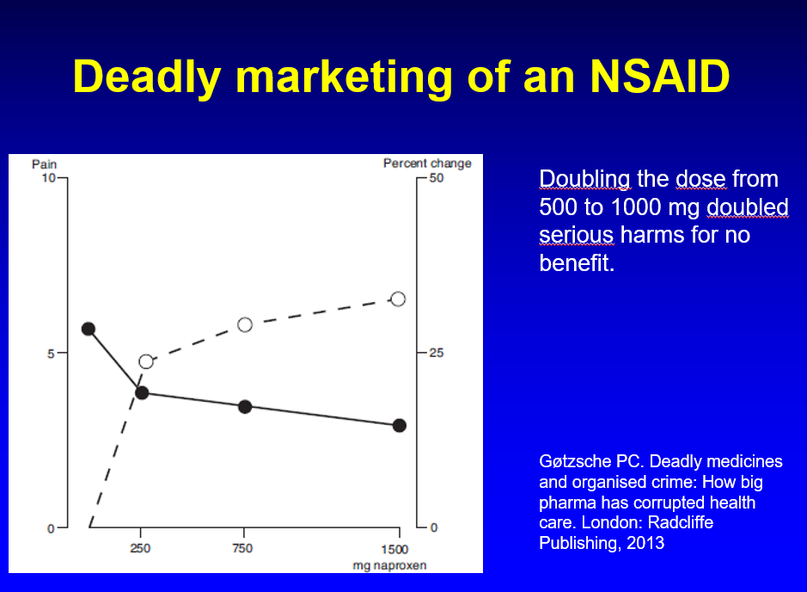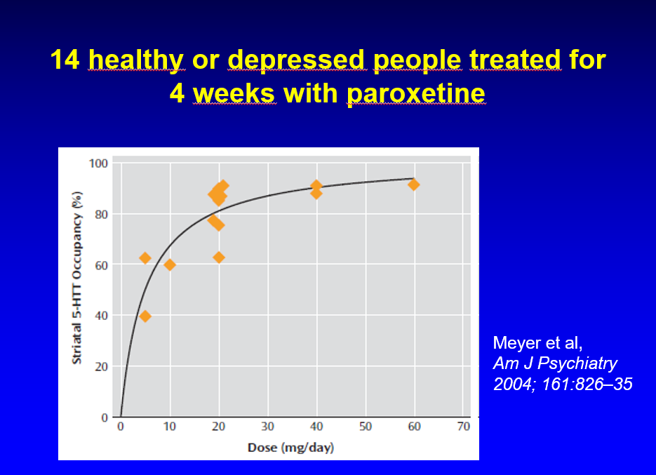

The difference between 250 mg and 1500 mg naproxen is six times in terms of money but only 1.0 cm on a 10 cm pain scale, and the least difference in pain patients can perceive is about 1.3 cm.

For other drugs, the dose-response relationship is also hyperbolic. For paroxetine, for example, there is no discernible increase in effect when increasing the dose from 10 mg to 20 mg or 40 mg (see figure).

My career as a whistleblower started with my doctoral thesis, “Bias in double-blind trials” from 1990, which summarised six of my papers. I had collected 196 head-to-head comparisons of NSAIDs and showed with statistical methods that the results couldn’t possibly be true. I demonstrated a huge amount of bias and errors, which consistently favoured the new drug over the control drug. It was particularly bad for the conclusion or abstract, where the bias favoured the control drug in one report and the new drug in 81 reports (p = 3.4 x 10⁻²³). This was the lowest p-value ever reported.
In many trials, the control drug was the old, off-patent drug indomethacin, which, according to the trial reports, was a poor drug compared to the newer, expensive ones. If this were true, the patients should prefer the newer drugs more often than indomethacin when asked which drug they preferred in cross-over trials where they had tried both drugs. They didn’t. When the patients added up their perceptions of the benefits and the harms of the drugs, they preferred indomethacin similarly often:

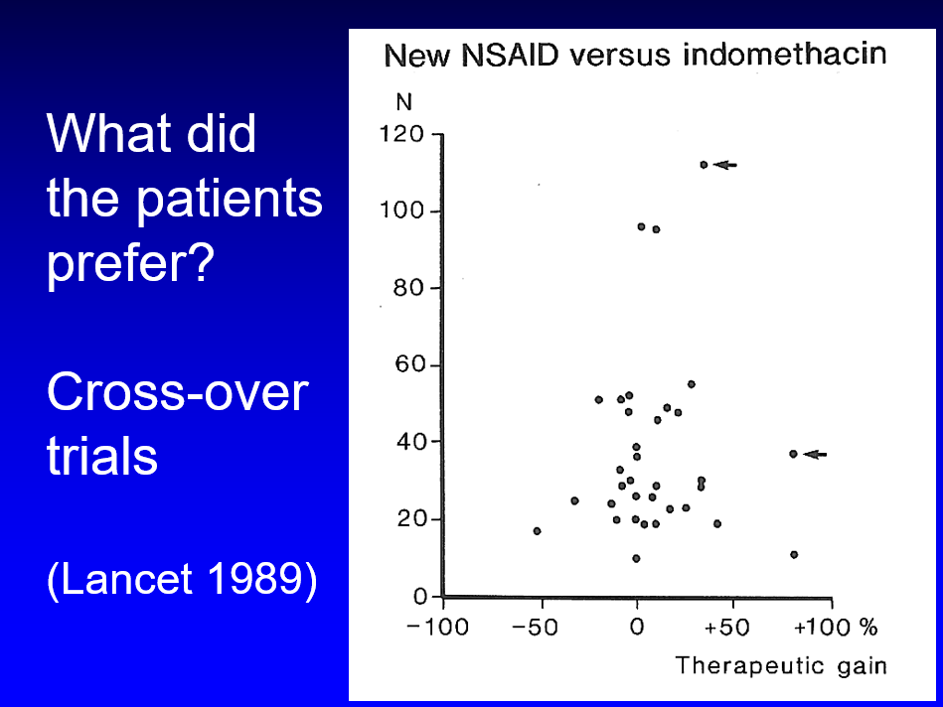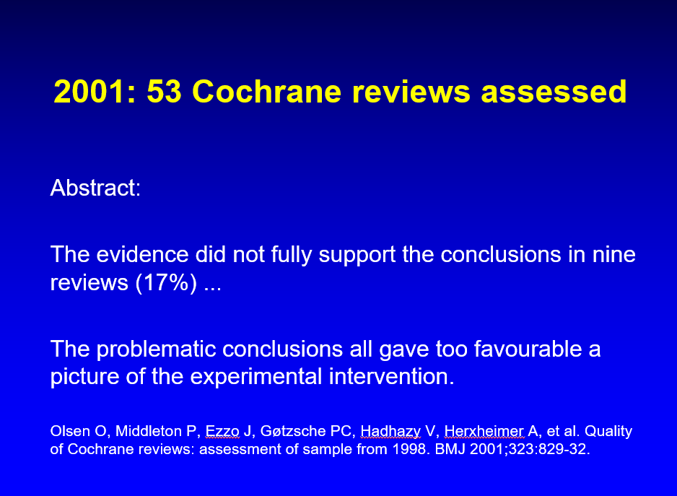

Mathematically, the collection of data points should be contained within a funnel, which they were, apart from two outliers, which represented fraudulent results.

Cochrane scandals

In 2001, my research team assessed the quality of 53 new Cochrane reviews. We identified major problems in 15 reviews (29%), and what particularly stood out was that the evidence did not fully support the conclusions in nine reviews (17%). All the problematic conclusions gave too favourable a picture of the experimental intervention.

The Cochrane leadership was vehemently against us publishing our observations. We had informed our Cochrane colleagues well ahead of publication, which was to our own disadvantage, as the Cochrane Steering Group put pressure on us not to publish the results. I was summoned to a Steering Group meeting to explain why we wanted to publish. I said that since we belonged to an organisation that constantly assesses and critiques others’ research and points out when inconvenient results are being suppressed, it would be wrong to suppress our own results, which would also be an act of censorship. I furthermore noted that it would demonstrate Cochrane’s strength that we were willing to criticise ourselves and explained that it was important for patients, doctors and others to know that conclusions of Cochrane reviews should be viewed with caution, and that they needed to read more than just the conclusion.

As it turned out, nothing untoward happened to Cochrane. In fact, our paper benefited Cochrane and led to other quality improvement initiatives than ours being undertaken. But later, Steering Group co-chair Jim Neilson noted that many in the Collaboration felt our review was misleading because it was out of date (which was not correct), embarrassing, and potentially damaging; further, one entity almost lost external financial support.

In science, we hold people accountable for what they publish, and it is not relevant if the assessment is embarrassing for some people. We could not have foreseen that one entity’s funding would come into question. I am pretty sure which review group it was. It performed so badly that it would have benefited Cochrane if it had not survived.
The same year, also in 2001, my research group became the victim of serious editorial misconduct. This was the biggest scandal in Cochrane’s history so far. Despite protracted negotiations, the Cochrane Breast Cancer group denied us the possibility of publishing the harms of screening (rates of mastectomy, tumourectomy and radiotherapy), although these were defined in the protocol the group had approved and published. We published the full review in The Lancet, which was much more of a Cochrane review than the stymied review that was published in the Cochrane Library.

When we published a review in The Lancet a year earlier, our conclusion that “screening for breast cancer with mammography is unjustified” created a media storm. Some months later, the editors of the Cochrane Breast Cancer Group disowned our work, pointing out that it “was not a Cochrane Collaboration systematic review, and has not been reviewed by Cochrane Breast Cancer Group editors,” which is a tactic that philosopher Arthur Schopenhauer in his book, “The art of always being right,” calls appeal to authority.

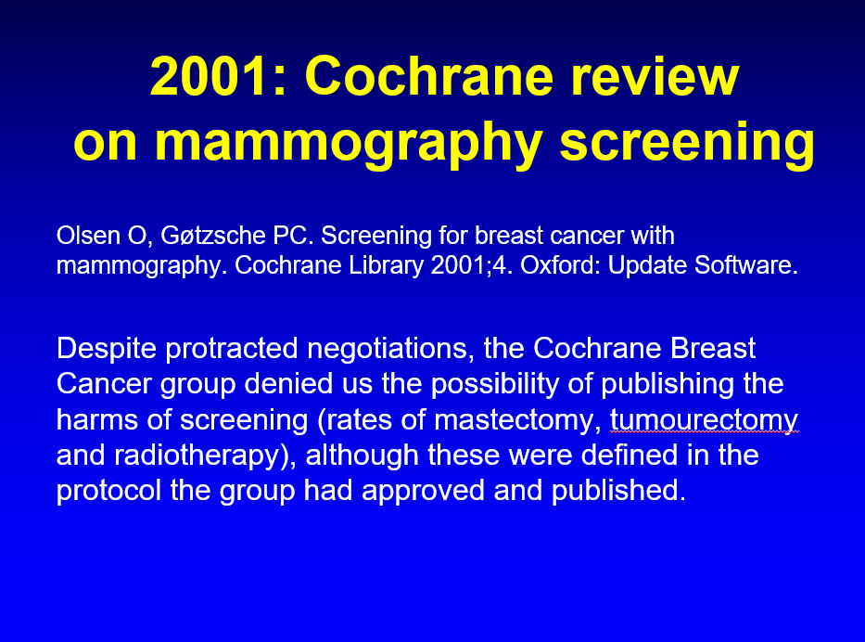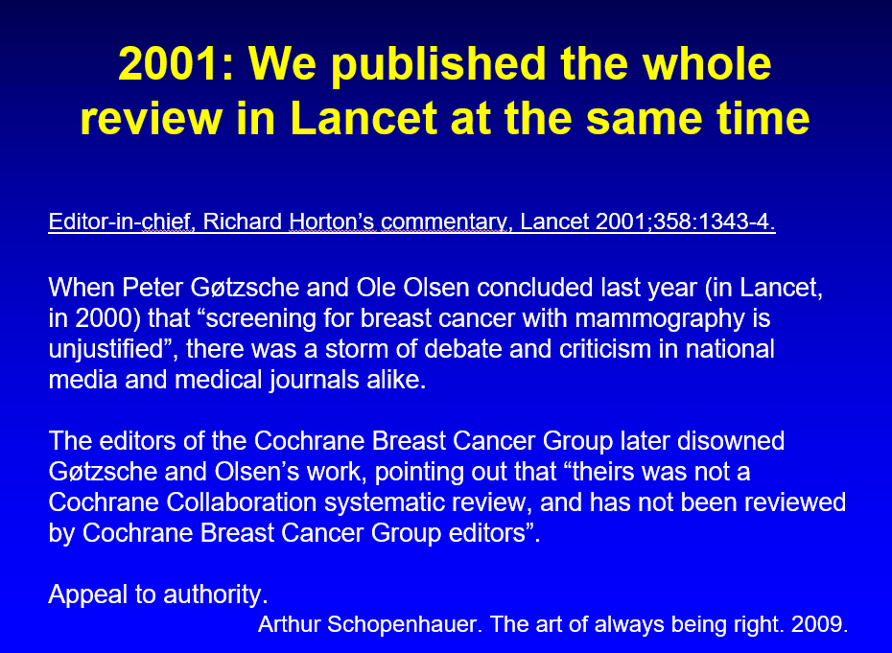

In 2001, Lancet’s editor-in-chief, Richard Horton noted in a scathing editorial, that even in the best organisations raw evidence alone is sometimes insufficient to influence opinion; that our conclusions were unwelcome; that the Cochrane Breast Cancer Group editors insisted that changes, we disagreed with, be made to the review if it was to be published in the Cochrane Library; that interference by Cochrane editors to insert what the authors of the overview believe to be invalid analyses erodes the academic freedom of these investigators; that interventions by either reviewers or editors to diminish the validity of Cochrane reviews should be a more prominent concern of the Collaboration; and that there is no reliable evidence from large randomised trials to support screening mammography programmes.

I described the many lies about mammography screening in 2012 in a book where I also explained the arduous process with getting the harms of screening published in our Cochrane review. This took five years, which fact made the Cochrane scandal much worse than it already was (see slides below).

In 2011, I asked if it was time to stop mammography screening, and in 2015, I explained why it should be abandoned because it is harmful and has no benefits. Screening does not lower total mortality and does not even lower total cancer mortality, which it should do if it had an effect on breast cancer mortality, which is an unreliable outcome, biased in favour of screening.

In 2013, I published the book, “Deadly medicines and organised crime: How big pharma has corrupted health care,” which won the British Medical Association’s Annual Book Award in the category Basis of Medicine in 2014. I translated it into Danish, and it has appeared in 16 other languages.

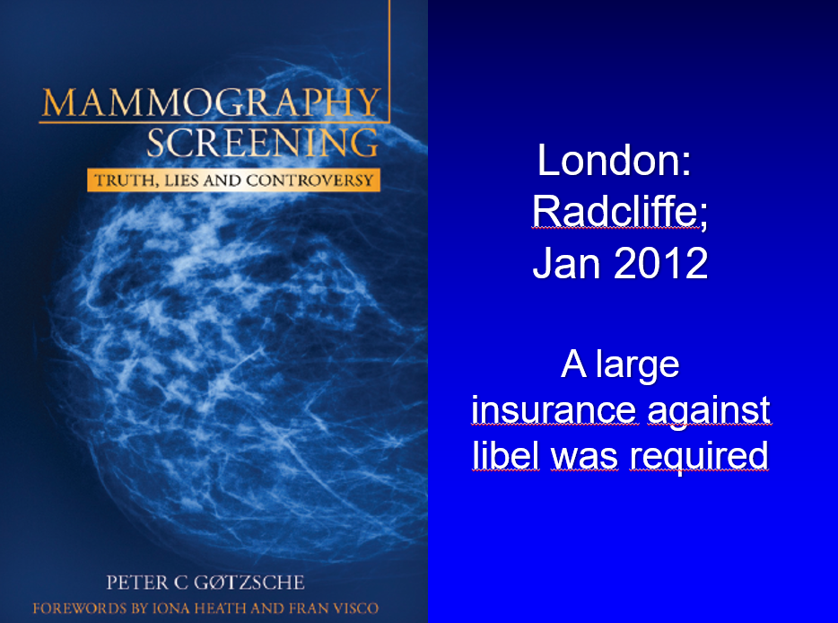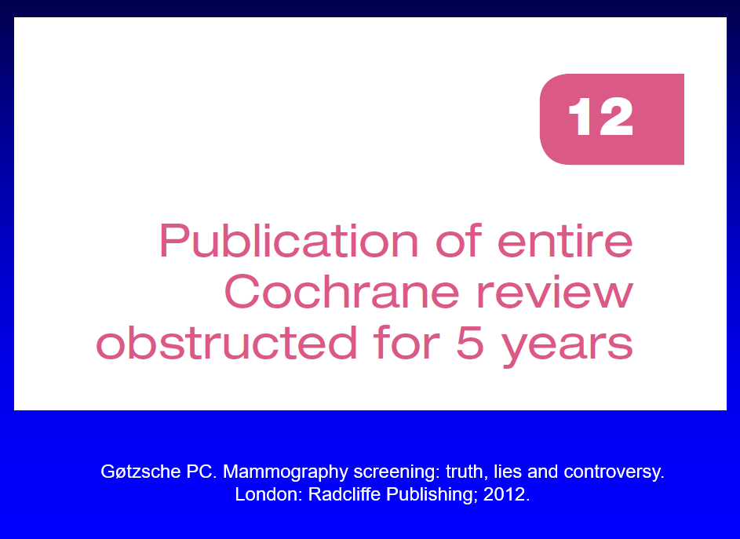

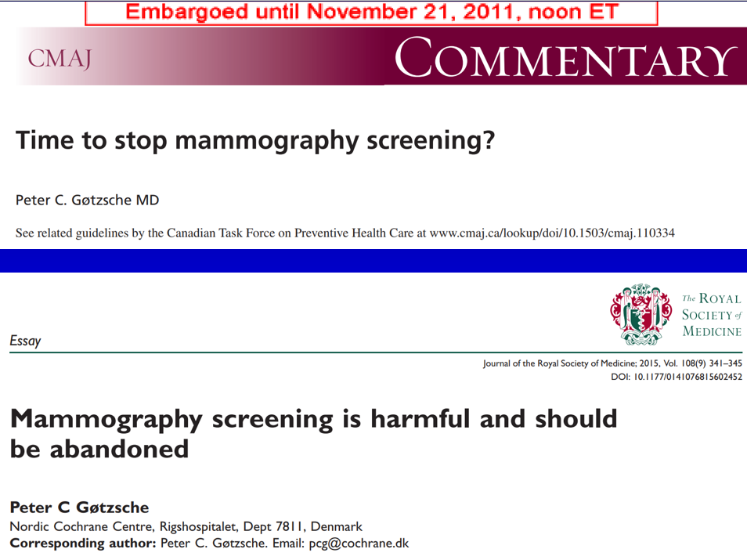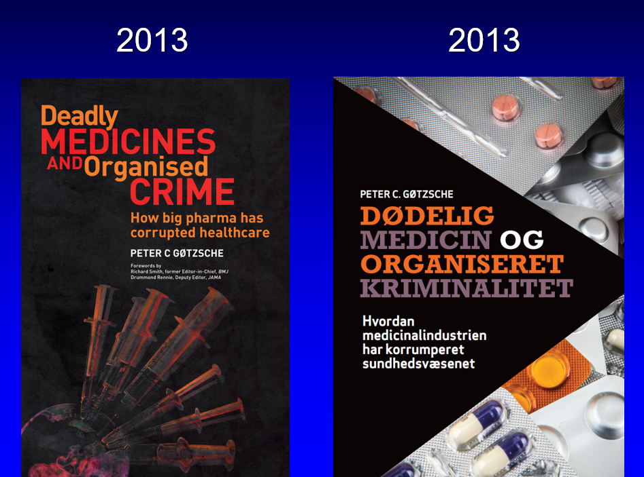

This book was very popular among patients but not among industry apologetic doctors. The president for the umbrella Organisation of the Danish Medical Societies, Peter Schwarz, wrote in an industry supported throw-away journal that:

“Evidence is one of the most noble concepts in the medical profession. This means that you have evidence to prove the claims you make. Professor Peter C. Gøtzsche violates strongly this principle in his book, which makes such outrageous claims about the medical profession as habitual criminals and the industry as a mafia that it is borders on dishonesty. The documentation Peter Gøtzsche uses to discredit Danish doctors is old and moreover, to a large extent, from abroad. It is deeply concerning that a person who calls himself an expert in the field, has apparently not followed what has happened in the area over the past 10-20 years.”

The Danish Association of the Pharmaceutical Industry came up with very similar “arguments.” This, Schopenhauer calls “Claim victory despite defeat.” There is none so blind as he or she who WILL NOT SEE. In my rebuttal, I wrote that, with over 900 references, my book was unusually well documented, and so were the crimes I described. And the ten cases I used to demonstrate that the ten largest pharmaceutical companies have a business model that meets the criteria for organised crime, were from 2007 to 2012.

I did not think Schwarz had read my book, which came out the day before his condemnations. And if it had been as terrible as he thought, it's hard to understand that a former editor of the British Medical Journal and an editor of the Journal of the American Medical Association praised it in their forewords.

In January 2014, I published an article in a major Danish newspaper that also came out in English. It described 10 myths in psychiatry, which are harmful for the patients, and I explained that:

“Many psychiatrists are well aware that the myths don’t hold and have told me so, but they don’t dare deviate from the official positions because of career concerns. Being a specialist in internal medicine, I don’t risk ruining my career by incurring the professors’ wrath and I shall try here to come to the rescue of the many conscientious but oppressed psychiatrists and patients by listing the worst myths and explain why they are harmful ...

Psychotropic drugs can be useful sometimes for some patients, particularly in short-term use, in acute situations. But after my studies in this area, I have arrived at a very uncomfortable conclusion: Our citizens would be far better off if we removed all the psychotropic drugs from the market, as doctors are unable to handle them. It is inescapable that their availability causes more harm than good. The doctors cannot handle the paradox that drugs that can be useful in short-term treatment are very harmful when used for years and create those diseases they were meant to alleviate and even worse diseases. In the coming years, psychiatry should therefore do everything it can to treat as little as possible, in as short time as possible, or not at all, with psychotropic drugs.”

In March 2014, the Danish Psychiatric Association attempted character assassination. They wrote to Cochrane and quoted me selectively, out of context: “Our citizens would be far better off if we removed all the psychotropic drugs from the market.”

The association appealed to authority; the opposite of what evidence-based medicine is about. They noted that I had been criticised by the Minister of Health, the director of the National Board of Health, the director of the Danish Patients Association, the president of the Cancer Society, the president of the Danish Psychiatric Association and the president of the Organisation of Danish Medical Societies.

They ended their letter to Cochrane by asking: “How do you, with the specific knowledge you have on antipsychotics and antidepressants, respectively, evaluate Peter Gøtzsche’s statements as presented in his article. We would be very pleased if you would take up the task of making such an evaluation.”

Cochrane did not attempt to consult with me before they responded. I sat in a jungle in Panama for a week and only learned about this later. Cochrane’s ill-considered reply threw me under the bus, which started a witch-hunt in Danish media because the psychiatrists propagated the reply.

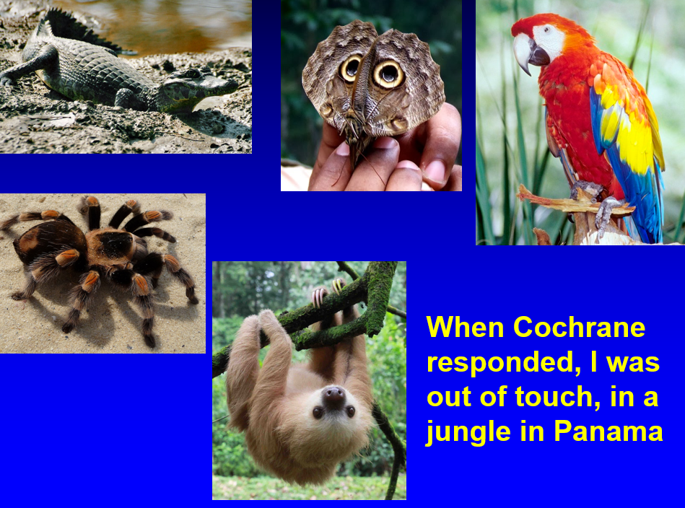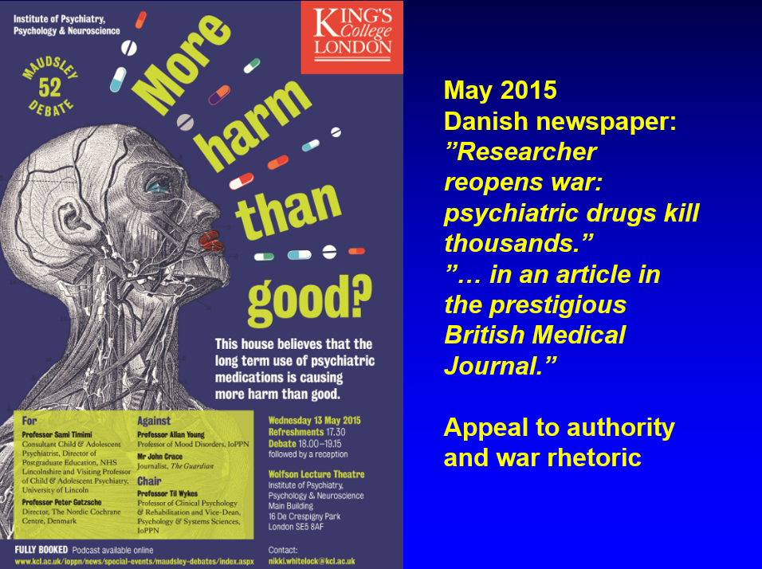

The whole press ran amok. I felt like the Roman senator who said: “You won’t succeed stabbing me in the back. I have so many scars already that the knife won’t get through.”

Ten months later, a BMJ paper with views very similar to mine appeared. No one paid any attention to it. The kangaroo court led by Cochrane’s CEO, journalist Mark Wilson, who had no scientific insight and who didn’t care about science either, had already done its work.

A conservative newspaper wrote that I did not have support “for a number of controversial statements about the drug industry and the use of psychiatric drugs” and that “the organisation doesn’t agree either with the views Peter Gøtzsche describes in his book where he compares the business model of the drug companies with criminal organisations.” (I had two chapters in my book about psychiatry, “Psychiatry, the drug industry’s paradise” and “Pushing children into suicide with happy pills.”)

Cochrane later rejected the journalist’s free fantasy: “We have not at any time expressed any opinion about Gøtzsche’s views about drug companies,” but it was too late. The damage was done. The appeal to authority had worked, as it usually does.

The letter from Cochrane’s leadership was a threat to what I had built up over 30 years, including my centre, which was on government funding. The Minister of Health threatened to fire me by declaring publicly that my person and the centre wasn’t the same thing.

I had not done anything wrong. I simply pointed out what I detailed in my book on psychiatry a year later, in 2015, and what many others had pointed out before me. But this was taboo:

Thou shalt not criticise the Emperor’s new drugs!

Particularly not in a country where the drug industry is the biggest source of income.

In 2015, I spoke at the prestigious Maudsley debate in London about psychiatric drugs. The key arguments from both sides were published in the BMJ, and Cochrane and the Danish media reacted with hostilities. A Danish newspaper used war rhetoric and appealed to authority (see slide above). Once again, this was eminence-based medicine versus evidence-based medicine, or “Power versus rationality.” My arguments for stopping 98% of psychotropic drug use were simple, and the evidence was clear.

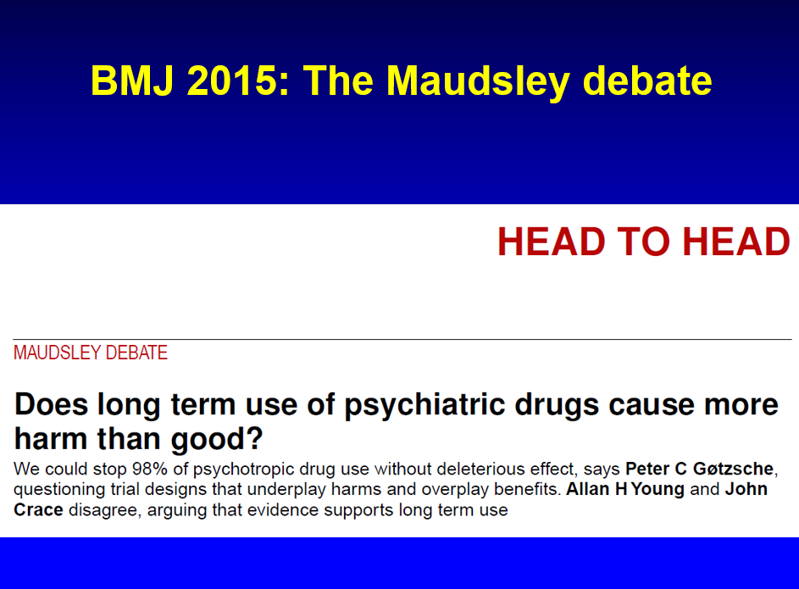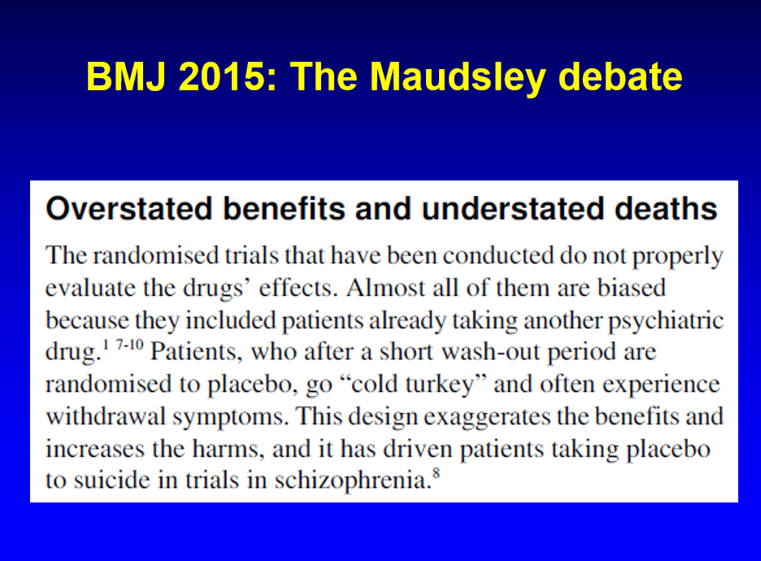

But yet again, Cochrane’s CEO wanted it otherwise. I had shown my article to Cochrane’s leadership as a courtesy before it came out, but my kindness was not returned. Cochrane’s editor-in-chief and the editors of the three Cochrane mental health review groups rushed and killed the messenger the same day that my article appeared in print, which was the day before the Maudsley debate. I found their arguments inappropriate and a disservice to patients and explained why, in the BMJ’s print issue.

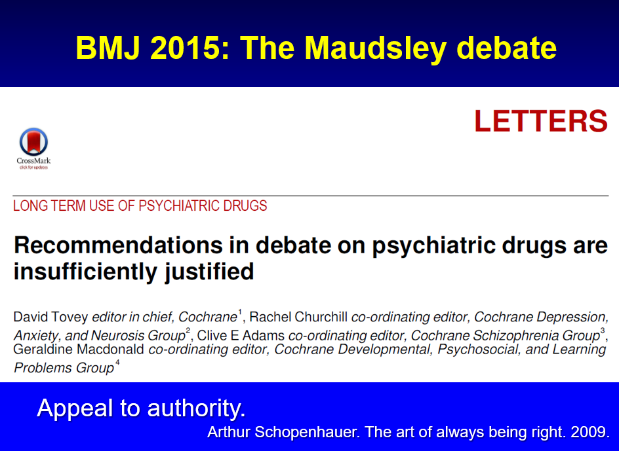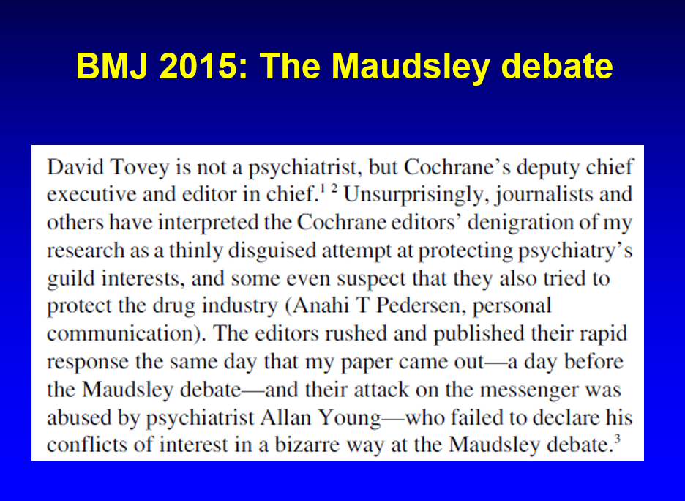

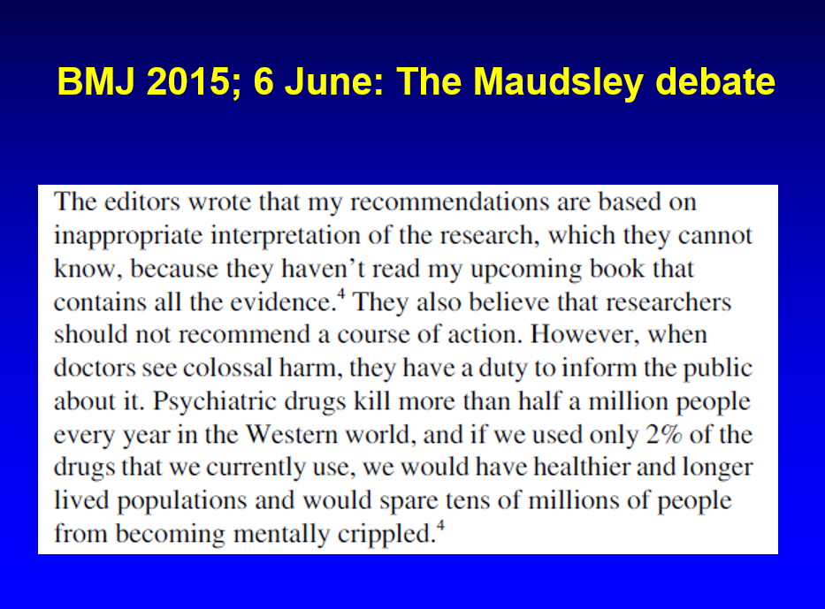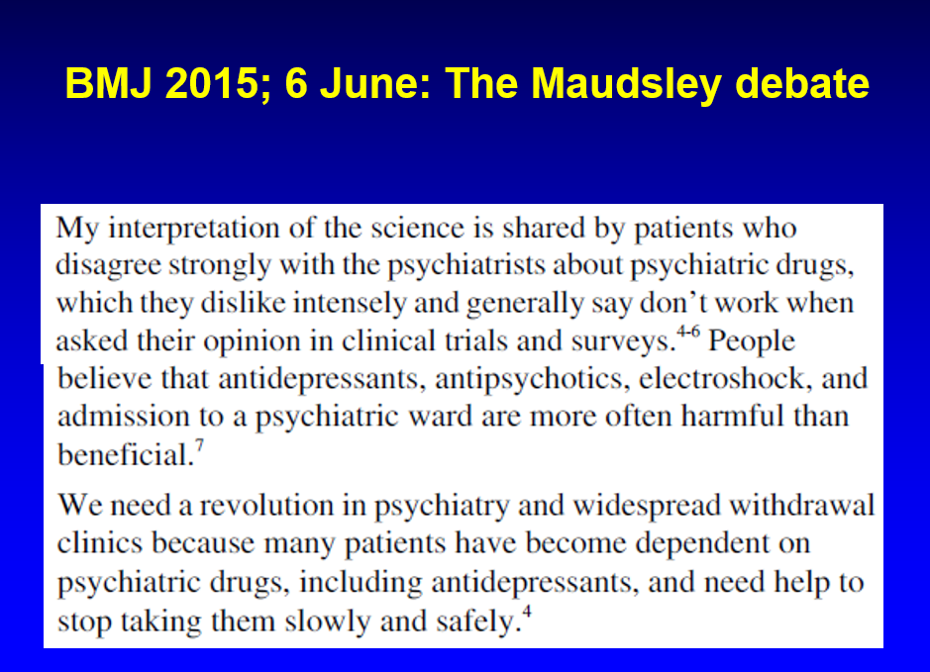

I noted that journalists and others had interpreted the Cochrane editors’ denigration of my research as a thinly disguised attempt at protecting psychiatry’s guild interests, and some even suspected that they also tried to protect the drug industry. This angered Wilson so much that he threatened to close my Cochrane centre. He forced me to issue an apology, which appeared on BMJ’s website:

“As I did not intend to question my four Cochrane colleagues’ integrity, I withdraw this statement to avoid any misunderstandings and I apologize for any hurt and confusion caused. The fact is that all of us in Cochrane do our best to keep industry influence out of our work, which we regard as essential for the trustworthiness of our reviews.”

This was a forced confession, and it wasn’t correct. Cochrane didn’t do its best to keep industry influence out, far from, neither then, nor now. Back then, half of the authors of a Cochrane review were allowed to be financially conflicted in relation to the drug company whose product they were evaluating. When I told this to other people, they got shocked, and when I got elected to the Cochrane Governing Board, I suggested that no one should be allowed to have such conflicts of interest.

I offered to rewrite the policy, which I did in an afternoon. But, oh no, this was not how Cochrane worked. After over two years of deliberations, Cochrane published its revolutionary new policy in 2019. Now, only one third of the authors were allowed to have such conflicts. I tweeted that Semmelweis never told doctors to wash one hand only; they should wash both. I also wrote that, “Cochrane’s ‘strengthened’ commercial sponsorship policy is like eating the cake and still having it. It is like going from declaring to your spouse that you are unfaithful half of the days in a month to ‘improving’ by declaring that from now on you will only be unfaithful one third of the days.”

In 2017 and 2018, the drug industry went into action. Neutral observers suspected it was a concerted action controlled by the industry when Danish media wrote defamatory articles. The most mendacious journalist, Kristian Lund, spread 63 lies about me in around 20 articles in his industry-supported throw-away journals. I complained to the Press Council that reprimanded him and I contacted politicians in the Danish Parliament, to no avail, of course. When evil people with psychopathic traits come after you, you are doomed, and I shall give more examples below.

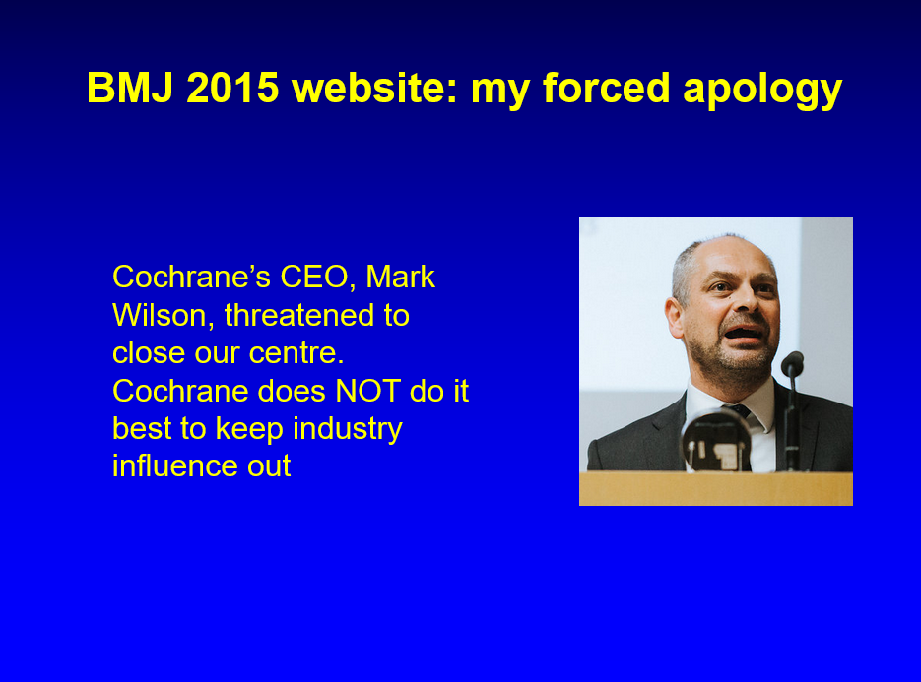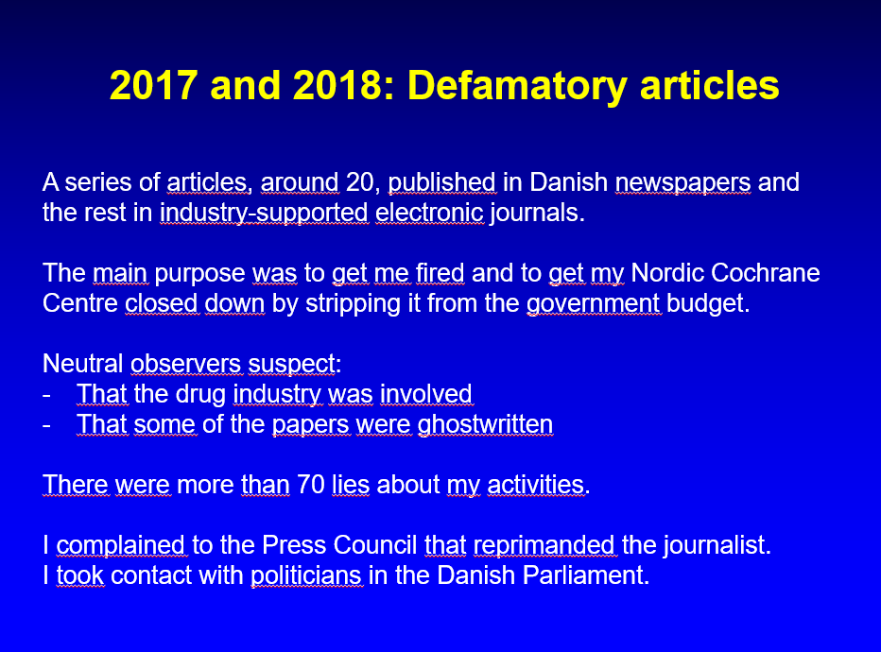

One of Lund’s blunt lies was: ”The confusion of his private economy and the centre's economy is worrying - or worse.” There was no such confusion. My hospital had made Lund – who had obtained access to my receipts over three years without finding anything wrong - aware of this fact more than once:

“Based on our ongoing administration and review of material related to inquiries from the Health Policy Journal, Rigshospitalet cannot recognize the Journal’s claim that a mix of private money, public funds and research funds takes place.”

If you can’t beat him, lie about him, as Schopenhauer says, and you’ll win. This lie was propagated by professor Trisha Greenhalgh from Oxford University who made it even worse. She claimed I lost my job because I had mixed my private expenses with those of my centre. I didn’t, and I never failed to comply with financial audits, which she also claimed.

Greenhalgh’s maliciousness contrasted to the impeccable character of the many friends I have in relation to Oxford. Shown on the photo below are Sir David John Spiegelhalter, Tom Jefferson, Douglas Altman, Victor Montori, Fiona Godlee, me, Sir Iain Chalmers, Andrew Oxman and Carl Heneghan. I have published over 50 papers with Altman, one of the world’s finest biostatisticians, more than with anybody else.

Greenhalgh published her fantasies in a Wiley journal and Wiley has a conflict of interest, as it also publishes the Cochrane Library. The journal first allowed me to publish a rebuttal, but then withdrew its offer. The printed version of the lie will stand forever, but the journal withdrew it in the electronic version saying it was “not directly supported by its stated source.” The use of the word “directly” was malicious, as it suggested that, after all, it could be true what Greenhalgh wrote. So, Wiley was also dishonest.
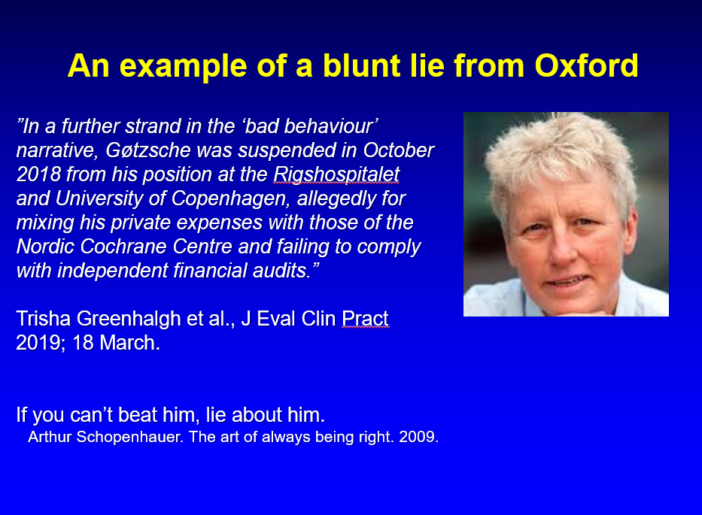

In 2018, Cochrane’s CEO, Mark Wilson, exposed me to a show trial after I had asked a US funder about the cause of death in a study of neuroleptics where many young people died and had written an expert report for the court in a Dutch double-homicide trial. Wilson claimed that I had broken the Spokesperson Policy by using the Nordic Cochrane Centre’s letterhead.

It was impossible that anyone could be in doubt that my views were my own and not official Cochrane policy or views. According to our rules, I appealed to the Cochrane Governing Board of which I was a democratically elected member, with the most votes of all 11 candidates, although I was the only one who, in my election statement, criticised the Cochrane leadership and its direction of travel.

A US lawyer, Ryan Horath, wrote on his blog: “JESUS CHRIST, WHAT IS WRONG WITH YOU PEOPLE? A researcher is making inquiries about the suppression of information regarding children who died in a clinical trial and everyone is worried about what letterhead it is written on?”

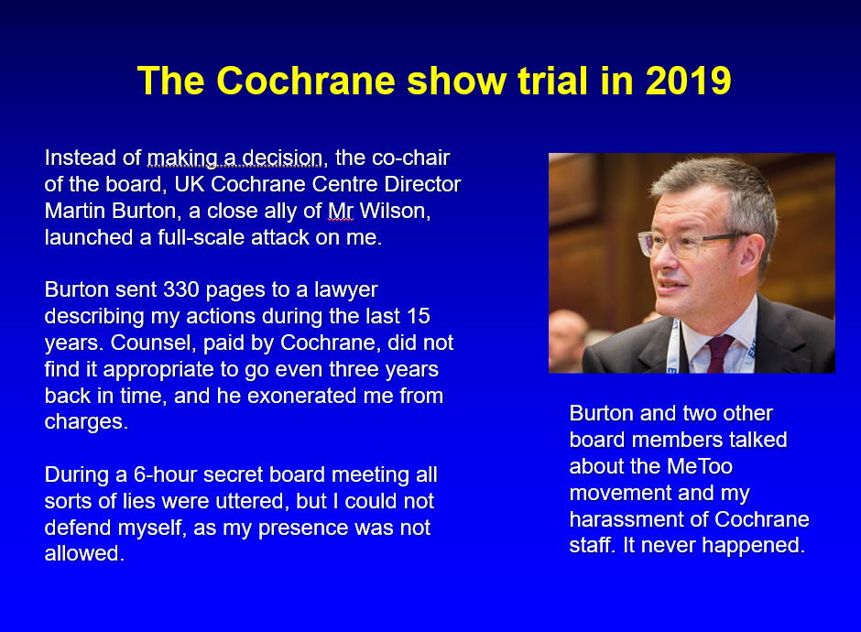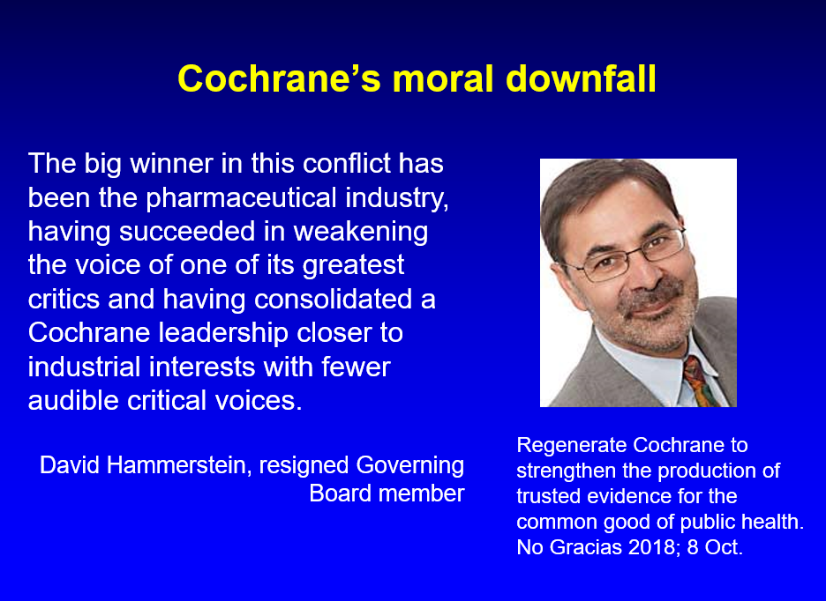

The co-chair of the Cochrane Governing Board, UK Cochrane Centre Director Martin Burton, a close ally of Wilson, launched a full-scale attack on me. He sent 330 pages describing my actions during the last 15 years to Cochrane’s lawyer. He exonerated me from all charges of wrongdoing, but this didn’t matter for Burton.

During a 6-hour secret board meeting, all sorts of lies were invented, but I could not defend myself, as my presence was not allowed. Burton and two other board members talked about the MeToo movement and my harassment of Cochrane staff. But it never happened.

I was kicked out of the Board of Trustees and from Cochrane following a close vote, 6 to 5. The next day, 4 of the 13 board members resigned in protest. Chaos ensued and there were condemning articles in Science, Nature, BMJ, Lancet, etc.

Four days later, Burton delivered a formidable hate speech at the Annual General Meeting that made people believe I had sexually harassed women or had committed serious repeated crimes. It was a pure invention to try and discredit me.

The official excuse was “bad behaviour,” which was never defined, despite questions from the audience. The real reason was that I was a threat to the CEO’s dictatorial regime in Cochrane and his emphasis on brand and business, rather than on getting the science right.

My criticisms of psychiatry, psychiatric drugs, the drug industry, and the highly prestigious Cochrane review of the HPV vaccines, which Tom Jefferson called garbage in, garbage out, with a nice little Cochrane logo on it, were justified.

Via freedom of information requests, my lawyer found out that Wilson had demanded of the Danish Ministry of Health and my hospital that I be fired, although he had no authority to demand such action. I got fired, despite over 10,000 signatures from leading researchers and others to the Minister asking her to prevent this.

We suspect that my firing was a political strategy. By getting rid of me, the Ministry demonstrated it supported the Danish drug industry, the drug agency, the National Board of Health, the psychiatrists, and others who didn’t like that there were people like me who spoke truth to power. People in leadership positions in the drug agency owned shares in Danish drug companies and so did the Minister of Health.

Commentators noted that Cochrane had de facto introduced scientific censorship and had become too close to industry. Its reputation plummeted when it expelled one of its most well-known scientists. BMJ’s editor-in-chief, Fiona Godlee, wrote that Cochrane should be committed to holding industry and academia to account, and that my expulsion from Cochrane reflects “a deep seated difference of opinion about how close to industry is too close.”

David Hammerstein, one of the board members who resigned in protest over my expulsion, wrote that “The big winner in this conflict has been the pharmaceutical industry, having succeeded in weakening the voice of one of its greatest critics and having consolidated a Cochrane leadership closer to industrial interests with fewer audible critical voices.”

I wrote a book about the Kafkaesque show trial and its consequences where I documented what happened during the secret boardroom meeting, after a recording was leaked by one of the board members who resigned in protest. I updated the book when a filmmaker and I agreed that we should make a documentary about the demise of Cochrane. This update is freely available.

When Sir Iain Chalmers issued an invitation to 50 people in 1993 to start the Cochrane Collaboration, he emphasised that the purpose of the first Cochrane Colloquium would be to launch the Collaboration as a truly international collaboration committed to opposing any tendency for it to become dominated by any nation, institution or individual.

Sadly, 25 years later, Cochrane was dominated by two people with psychopathic traits, Mark Wilson and Martin Burton, who cared little about the truth and procedural fairness and who violated all the pivotal rules for charities and for Cochrane itself during the show trial against me.

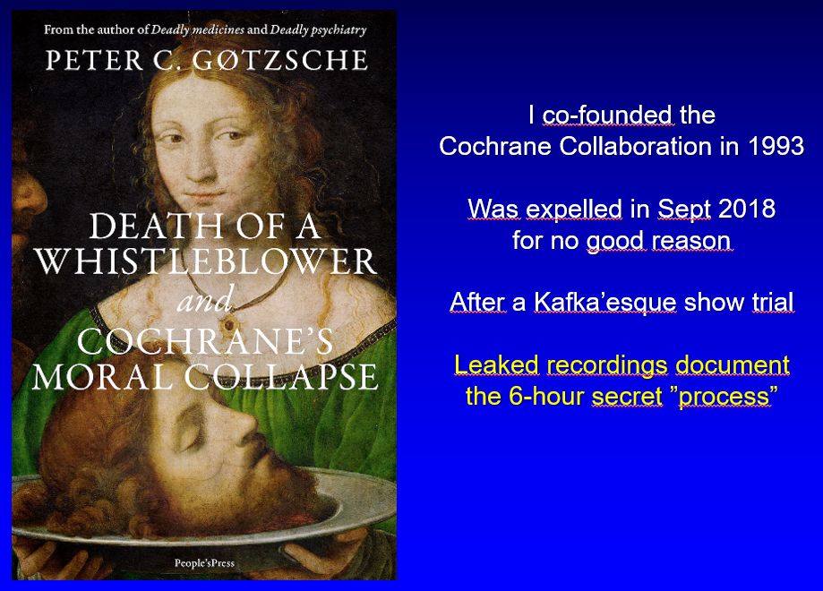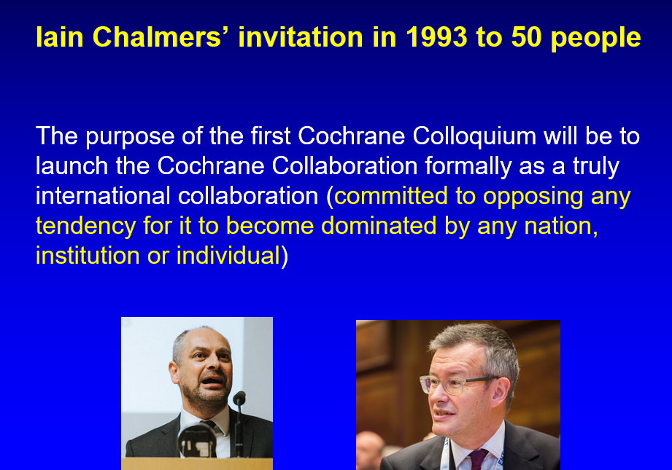

I delivered my last words to Cochrane during the discussion section at the Annual General Meeting after Burton’s hate speech: “I shall survive, but I'm worried about Cochrane.” A Spanish doctor exposed the Cochrane tragedy with a cartoon:

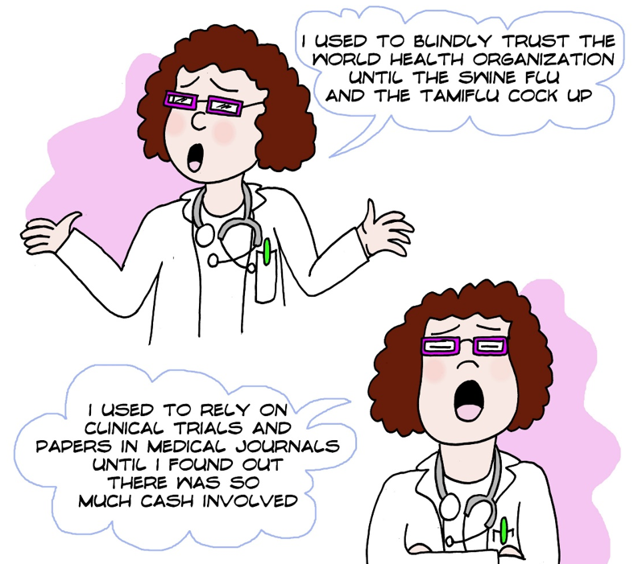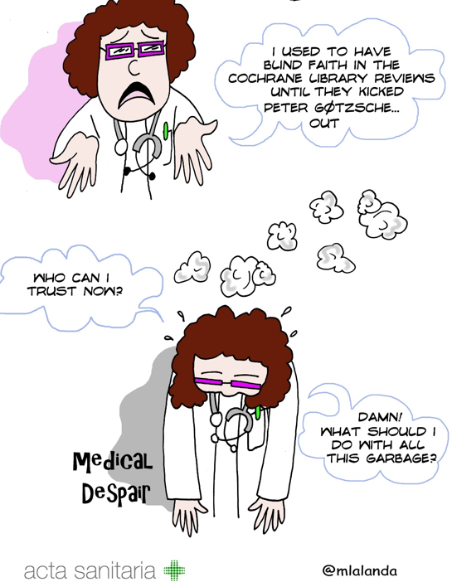

My final words are these:

If you are neutral in situations of injustice, you have chosen the side of the oppressor. If an elephant has its foot on the tail of a mouse and you say that you are neutral, the mouse will not appreciate your neutrality (Desmond Tutu).

The only thing necessary for the triumph of evil is for good men to do nothing (Edmund Burke).

