“Why we resigned” from the Cochrane Governing Board

By Peter C Gøtzsche
Institute for Scientific Freedom
Copenhagen

6 November 2023

The day after I was expelled from the Cochrane Governing Board and from the Cochrane Collaboration on 13 September 2018, four board members resigned in protest. Two days later, they gave their reasons in an email, “Why we resigned,” which they sent to Cochrane colleagues asking them to help distribute the letter to others. They also uploaded their letter on the Austrian Cochrane Centre’s website but were immediately asked by Cochrane’s leadership to remove it, which they did. One of Cochrane’s key principles is transparency. I therefore bring the letter below, which Cochrane misrepresented in a defamatory way.

Child and adolescent psychiatrist Sami Timimi read my book about this affair and wrote in a book review: “This book carefully recounts this dark period in medical science where a once trusted institution carried out one of the worst show trials ever conducted in academia. The CEO and his collaborators went about their task in a manner that mirrors how the drug industry operates.”

The four resigned board members were thanked by commentators for their moral courage and decency. They saw the affair as a leadership crisis with a lack of respect for all those members of Cochrane who had voted for me in a democratic election (I got the most votes even though I was the only one of 11 candidates who had criticised the Cochrane leaders in my election statement). They were shocked about the “intolerance to differing views” and the CEO’s brutal attack on freedom of speech when someone spoke truth to power, which suggested to them that the CEO, journalist Mark Wilson, had become too sensitive to criticism of the pharmaceutical industry.

Cochrane’s brutality continued. At the Annual General Meeting, four days after my expulsion, co-chair of the board, UK Cochrane Centre director Martin Burton, impugned the reputation of the four resigned board members by claiming that they had “actively disseminated an incomplete and misleading account of events.”

This was not correct. What was misleading, indeed seriously so, was Cochrane’s official statement about why I was expelled.

Because their actions were indefensible, it was essential for Wilson and his close ally Burton that they suppressed the truth. This involved that Wilson took control over my Nordic Cochrane Centre’s website behind my back, even though I was still its director, and uploaded Cochrane’s defamatory and mendacious statement about me there.

With leaders like this, who are now both gone, it is no surprise that Cochrane today is in great trouble (see my freely available book). Here is the four board members’ resignation letter:

Edinburgh, September 15, 2018
Dear Cochrane Colleagues,

This week, the Cochrane Governing Board decided with a vote of 6 in favour, 5 opposed, and one abstention, to expel Peter Gotzsche from his membership in Cochrane because he has been "causing disrepute" to Cochrane.

Four of us who opposed this decision have resigned from the Board as a result. We consider the Board’s use of its authority to expel Peter from Cochrane to be disproportionate. The general public, consumers, students, and researchers involved in Cochrane value the plurality of opinions, views, and perspectives Cochrane has worked hard to give voice to since its foundation. We believe that the expulsion of inconvenient members from the Collaboration goes against Cochrane ethos and neither reflects its founding spirit nor promotes the Collaboration’s best interests. We are concerned that these actions might cause great damage to the reputation of the Collaboration.

Governing Board members are expected to publicly uphold and defend all decisions taken. We could not adhere to this obligation in this case in good conscience. We also believe that those of you, who placed your trust in us to represent you on the Board, would not wish us to do so. For this reason, we have unfortunately felt the need to resign from the Cochrane Governing Board and have done so the day after the decision was taken.

It is our hope and deepest desire that this event will encourage all Cochrane members and the wider community to reflect upon where we currently find ourselves and give serious consideration to what we want for the future of Cochrane and its principles, objectives, and ethos.

Gerald Gartlehner, David Hammerstein, Joerg Meerpohl, Nancy Santesso

One month after my expulsion, I was still the director of my centre and held its 25th anniversary research symposium as planned. I had asked Tom Jefferson to tell the audience why we should not use Tamiflu for influenza, but he started his talk with something else that made the audience laugh out loud:

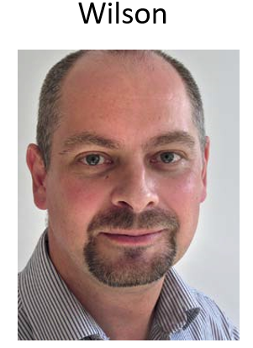
When Sir Iain Chalmers issued an invitation to 50 people in 1993 to start the Cochrane Collaboration, he emphasised that it should be committed to opposing any tendency for it to become dominated by any nation, institution or individual.

Sadly, 25 years later, Cochrane was dominated by two people from England with psychopathic traits, above all by Wilson who was in total control, also over the Governing Board, which was otherwise supposed to control him. Wilson had a past as a journalist in the Soviet Union and, like Stalin, he knew how to manipulate history, stepping into territories that were not his without getting permission, and taking credit for what others had achieved. Even his CV looked to good to be true. As one investigative journalist said: “He forgot to say he was on the Moon.” All alarm bells should have rung, but no one investigated if these impressive results were true when Cochrane employed him as CEO in 2012 and he started its Titanic course towards the iceberg and his persecutions of those who had created Cochrane including the directors of the US and French Cochrane centres.

Jefferson also showed these slides:

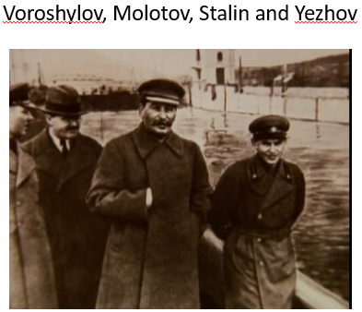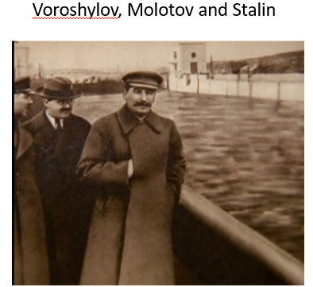

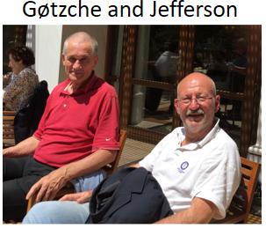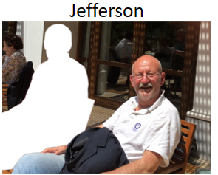

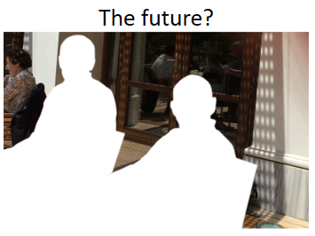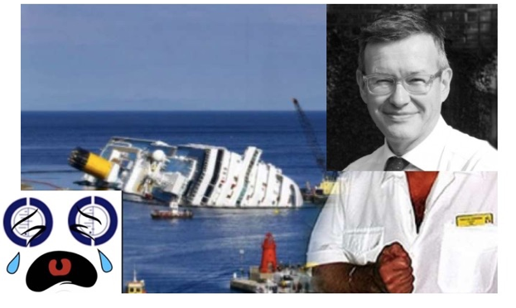

This is the shortest summary of Cochrane’s recent history that I can imagine. It can be understood without words. Three days after my expulsion, Maryanne Demasi published, “Cochrane – a sinking ship?” As the last slide suggests, Cochrane’s actions in 2018 were a disaster, and we can only weep at our loss, while Martin Burton is smiling about having transformed Cochrane into a ship wreck on his captain’s orders.

All the UK Cochrane groups have now lost their funding, which - ironically, because it was due to my effort - makes Denmark the biggest contributor to Cochrane.

