Does USA have the worst healthcare system in the world?

By Peter C Gøtzsche
Institute for Scientific Freedom

29 March 2024

The late Bernard Lown (Harvard cardiologist and Nobel Peace Prize recipient) said that capitalist medicine results in two things: undertreatment for people without money or insurance, and overtreatment of those with money.

This is the situation in US healthcare, and I wrote about it in my 2013 book, “Deadly medicines and organised crime: How big pharma has corrupted health care.” I documented that US healthcare is one of the worst in the world. Here is what I wrote:

Keeping people healthy is not a priority in America’s profit-driven system, which thrives when people are ill.¹ The propaganda has made nearly half of all Americans believe that the United States has the best healthcare in the world, albeit with a clear political divide (68% of the Republicans and 32% of Democrats).²

The beliefs that what is good for big pharma is also good for the people and that market forces will solve all problems are contradicted by the facts. The Unites States has the most ineffective healthcare system in the developed world.^{3,4} The three countries with the lowest healthy life expectancies, Hungary, Poland and Slovakia, are former communist countries:

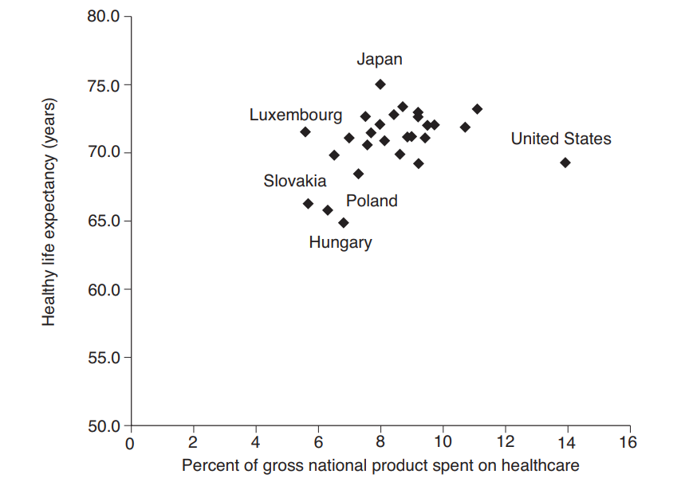

The Unites States has a relatively low healthy life expectancy despite the fact that this coun-try uses far more resources than any other country. A 2008 report from the Commonwealth Fund found that the Unites States ranked last among 19 industrialised countries across a range of measures of healthcare.⁵ The report estimated that if the United States attained the same performance indicators achieved in other industrialised countries, at least 100,000 lives and at least $100 billion could be saved every year, and it tied much of the problem to a weak base of primary care doctors. A study that compared 3075 US counties found that every 20% increase in primary care physicians was associated with a 6% reduction in total mortality.⁶ The relative position of the United States on health indicators among OECD countries also worsened in the period where the proportion of specialists increased.

The waste in the United States is gigantic. In relation to the size of the population, the Unites States spent 2.7 times more on drugs than European countries in 2000, and yet – or perhaps because of this – the outcome is much worse.⁷

The data in the figure are about 10 years old; currently, the Unites States is even worse off than in the figure, as it spends about 18% of its GDP on healthcare,⁸ 22 about double as much as in other industrialised countries.

The health disadvantage of Americans is not only because of extreme income inequalities and widespread poverty. It is also seen among those with a health insurance, a college education, higher incomes and healthy behaviours. Even for deaths considered amenable to health care, Americans fare poorly. The decline in amenable mortality in 19 industrialised countries averaged 16% over a 5-year period, whereas it was only 4% for the United States.⁹ What is also striking in the figure is that there isn’t any relation between the amount of money spent on healthcare and life expectancy.

The United Kingdom has come to resemble the United States more and more, as it has moved towards greater privatisation of healthcare. Its healthy life expectancy is lower than in most other European countries, and its prevalence of chronic disease and disability lies between that in the Unites States and the rest of Europe.¹⁰

Such sobering facts tell us so clearly that capitalism and privatisation impact negatively on public health and they explain why the vast majority of European doctors are left wing when it comes to healthcare. We feel nervous about profit taking any role in the caring professions, even those of us who might be right wing for other political issues. We love our public health service, which US politicians scornfully call socialised medicine.

Citation: Gøtzsche PC. Deadly medicines and organised crime: How big pharma has corrupted health care. London: Radcliffe Publishing; 2013, chapter 21: General system failure calls for a revolution.

References

1 Petersen M. Our Daily Meds. New York: Sarah Crichton Books; 2008.
2 Brownlee S. Overtreated: why too much medicine is making us sicker and poorer. New York: Bloomsbury; 2007.
3 World Health Organization. World Health Report 2003 – shaping the future.
4 Reinhardt UE, Hussey PS, Anderson GF. U.S. health care spending in an international context. Health Aff (Millwood). 2004;23:10–25.
5 Roehr B. Health care in US ranks lowest among developed countries, Commonwealth Fund study shows. BMJ 2008;337:a889.
6 Starfield B, Shi L, Grover A, et al. The effects of specialist supply on populations’ health: assessing the evidence. Health Aff (Millwood) 2001;March 15.
7 World Health Organization. The World Medicines Situation (undated, accessed 6 Feb 2013).
8 Wealth but not health in the USA. Lancet 2013;381:177.
9 Nolte E, McKee CM. Measuring the health of nations: updating an earlier analysis. Health Aff (Millwood) 2008;27:58–71.
10 Avendano M, Glymour MM, Banks J, et al. Health disadvantage in US adults aged 50 to
74 years: a comparison of the health of rich and poor Americans with that of Europeans. Am J Public Health 2009;99:540–8.

